

Grandstream Networks, Inc.
DP750/DP720

User Guide

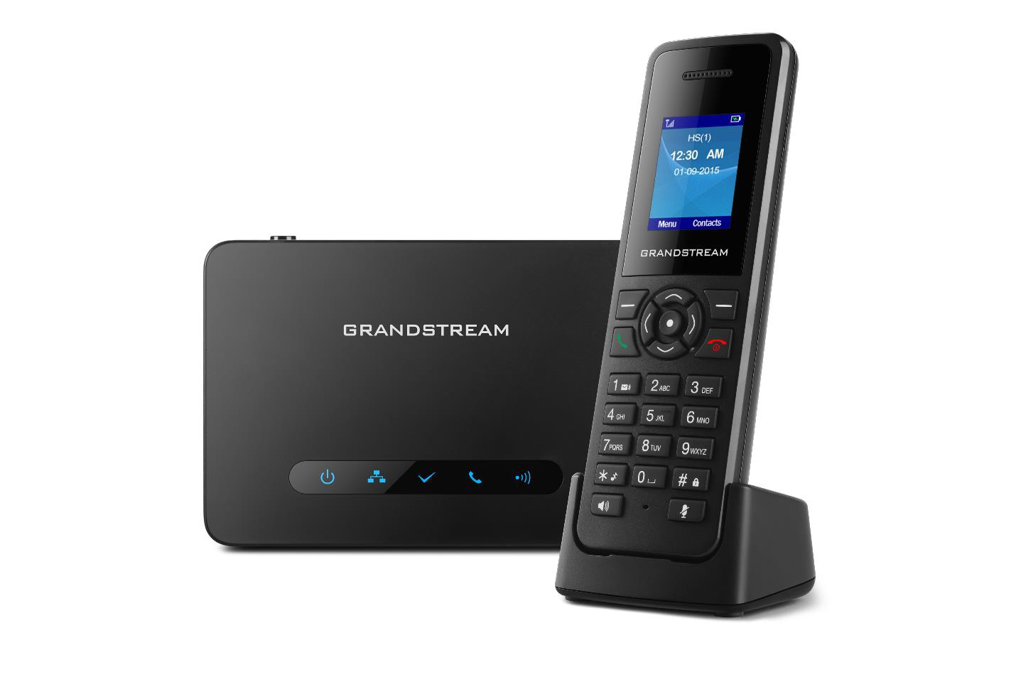

COPYRIGHT

©2016 Grandstream Networks, Inc. http://www.grandstream.com

All rights reserved. Information in this document is subject to change without notice. Reproduction or transmittal of the entire or any part, in any form or by any means, electronic or print, for any purpose without the express written permission of Grandstream Networks, Inc. is not permitted.

The latest electronic version of this user manual is available for download here: http://www.grandstream.com/support

Grandstream is a registered trademark and Grandstream logo is trademark of Grandstream Networks, Inc. in the United States, Europe and other countries.

CAUTION

Changes or modifications to this product not expressly approved by Grandstream, or operation of this product in any way other than as detailed by this User Manual, could void your manufacturer warranty.

WARNING

Please do not use a different power adaptor with your devices as it may cause damage to the products and void the manufacturer warranty.

DP750/DP720 User Guide | P a g e | 1

GNU GPL INFORMATION

DP750 firmware contains third-party software licensed under the GNU General Public License (GPL). Grandstream uses software under the specific terms of the GPL. Please see the GNU General Public License (GPL) for the exact terms and conditions of the license.

Grandstream GNU GPL related source code can be downloaded from Grandstream web site from:

http://www.grandstream.com/sites/default/files/Resources/gpl_dp750.tar.gz

DP750/DP720 User Guide | P a g e | 2
Table of Content

DOCUMENT PURPOSE 8

CHANGE LOG 9

Firmware Version 1.0.2.16 9

Firmware Version 1.0.1.14 9

Firmware Version 1.0.1.4 10

Firmware Version 1.0.0.16 10

GUI INTERFACE EXAMPLES 11

WELCOME 12

PRODUCT OVERVIEW 13

Feature Highlights 13

DP750 Technical Specifications 14

DP720 Technical Specifications 15

GETTING STARTED 17

Equipment Packaging 17

Connecting DP750 18

Connecting via AC power 18

Connecting via PoE 18

Setting up DP720 handset 19

Battery Information 19

Setting up the Charge Station 20

DP750 LED Patterns 20

DP720 Handset Description 21

DP720 Icons Description 22

DP720 Handset Menu 25

BASIC OPERATIONS 28

Turning the Handset ON / OFF 28

Register DP720 Handset to DP750 Base Station 28

Using DP720 with multiple DP750 base stations 29

Registering DP720 to an additional DP750 base station 29

Switching between different base stations 30

Unregister the DP720 31

Obtain DP750 Base Station IP Address via paired DP720 31

Setting the Key Lock 32

DP750/DP720 User Guide ^{P a g e | 3}
Locating a DP720 Handset from DP750 Base station 32

Locate via DP750 Web UI 32

Locate via DP750 Base station 33

Checking System Status 33

Basic Network Settings 34

Register a SIP Account 35

Register account via web user interface 35

Return to Idle Screen 37

Change Menu and Backlight Timeout 37

PHONE SETTINGS 38

Editing the Handset’s name 38

Changing the Base PIN Code 38

Selecting the Menu Language 39

Activate/Deactivate Hands-Free Mode 40

Muting the Microphone 40

Adjusting Speaker and Earpiece Volume 40

Ringtones 41

Setting the Ringer Volume on the Handset 41

Setting the Ringer Melody on the Handset 41

Advisory Tones 42

Date and Time 43

Outgoing Default Line 44

Factory Functions 44

Firmware Upgrade 45

Reboot DP750 Base Station 46

Reset DP720 Handset 46

CALL OPERATIONS 47

Placing calls 47

Make a Call using a Line 47

Dialing from Call history 48

Dialing from Phonebook 48

Answering Calls 49

Ending Calls 49

Rejecting Calls 49

Auto Answer 49

Direct IP Call 50

Call Hold/Resume 50

Call Waiting 50

Do Not Disturb 51

Call forward 51

DP750/DP720 User Guide ^{P a g e | 4}
Call transfer 52

Blind Transfer 52

Attended Transfer 52

Speed Dial 52

3-Way Conference 53

Voice Mail 53

Set Voice mail feature code 53

Play voice mail messages 53

Call Features 54

RESTORE FACTORY DEFAULT SETTINGS 56

EXPERIENCING DP750/DP720 57

DP750/DP720 User Guide | P a g e | 5
Table of Tables

Table 1: DP750 Features in a Glance 13

Table 2: DP720 Features in a Glance 13

Table 3: DP750 Technical Specifications 14

Table 4: DP720 Technical Specifications 15

Table 5: Equipment Packaging 17

Table 6: DP750 Led Patterns 20

Table 7: Handset Keys Description 21

Table 8: DP720 Icons Descriptions 22

Table 9: DP720 Info description 33

Table 10: Call Features 54

DP750/DP720 User Guide | P a g e | 6
Table of Figures

Figure 1: DP720 Package Contents 17

Figure 2: DP750 Package Contents 17

Figure 3: DP750 Back View 18

Figure 4: Connecting the Base station 18

Figure 5: Setting up the DP720 19

Figure 6: Setting up the charger station 20

Figure 7: Handset Keys Description 21

Figure 8: DP720 Menu Structure 25

Figure 9: DECT Status - Subscribe 28

Figure 10: Registration process 29

Figure 11: Multiple Base Stations Registration 30

Figure 12: Switching Between Base Stations 30

Figure 13: Locate Handset via Web UI 33

Figure 14: Network Settings configuration 34

Figure 15: SIP Settings 35

Figure 16: Sip Accounts Settings 36

Figure 17: Account Status 37

Figure 18: Handset Name editing 38

Figure 19: Changing Admin Base PIN Code 39

Figure 20: Handset Language 40

Figure 21: Ringer Volume 41

Figure 22: Calls Ringtones 42

Figure 23: Advisory Tone 43

Figure 24: Date and Time Settings 43

Figure 25: Factory Functions 45

Figure 26: New Firmware Available Notification 45

Figure 27: Firmware Upgrade 45

Figure 28: Rebooting the Base Station 46

Figure 29: Resetting the Base Station 46

DP750/DP720 User Guide | P a g e | 7
DOCUMENT PURPOSE

This document describes the basic concept and tasks necessary to use and configure your DP720 via the LCD menu and also using the DP750 base station. And it covers the handset installation, basic operations and call features. Please visit http://www.grandstream.com/support to download the latest “DP750/DP720 User Guide”.

This guide covers following topics:

- Product Overview

- Getting Started

- Basic Operations

- Phone settings

- Call Operations

DP750/DP720 User Guide | P a g e | 8
CHANGE LOG

This section documents significant changes from previous versions of user guide for DP750/DP720. Only major new features or major document updates are listed here. Minor updates for corrections or editing are not documented here.

Firmware Version 1.0.2.16

- Re-arranged the Handset Menu Settings. [DP720 Handset Menu]

- Changed menu “Line Status” in Call Settings to “Lines”. [Lines]

- Changed menu “Number” in set voice Mail to “VM Access Number”.

- Added headset detection and icon for DP720 dial mode screen. [DP720 Icons Description]

- Added ability to bridge conference before third party answers. [3-Way Conference]

- Added ability to reboot from DP720 handset. [Reboot DP750 Base Station]

- Improved alarm snooze icon. [DP720 Icons Description]

- Added DP720 LCD auto turn on feature when pickup from or reposition to charger.

- Added + button support for keypad dialing. [DP720 Handset Description] [Make a Call using a Line]

- Added Serbian, Slovakian languages.

- Improved support for Czech, Dutch, German, Hebrew, Japanese, Korean, Turkish languages

Firmware Version 1.0.1.14

- Added snooze time settings for alarm function. [Alarm Settings]

- Added snooze icon. [DP720 Icons Description]

- Updated alarm icon. [DP720 Icons Description]

- Removed IVR (Interactive Voice Response).

- Added contact name to delete confirmation.

- Added use Line from Contacts when dialing out of phonebook. [Dialing from Phonebook]

- Added VM, missed calls, headset icon. [DP720 Icons Description]

- Removed “Intercom” feature.

- Removed “Internal Call” from audio ring tone menu.

- Adjusted Call History and Contacts menu architecture. [DP720 Handset Menu]

- Moved "Edit Dial" option to last one in Call History and Contacts menu option. [Dialing from Call history] [Dialing from Phonebook]

- Hide empty fields when displaying contact info.

- Hide icon after press back key in idle misses call or VM alert screen.

- Moved “Standard ring” to last one of ring tone list. [Ringtones]

- Missed Call can be dialed back via related SIP profile using softkey.[Dialing from Call history]

DP750/DP720 User Guide | P a g e | 9
Firmware Version 1.0.1.4

- Added Call and Delete softkeys during off-hook dial. [Placing calls]

- Added left softkey for Voice mail alert window to enter the Play Message window. [Play voice mail messages]

- Added Display line name info immediately after off-hook. [Placing calls]

- Changed to only press ESC key to show factory menu.

- Added Dial number immediately after off-hook.

- Added Dialing GUI enhancements.

- Added ability to configure menu key timeout. [Change Menu and Backlight Timeout]

- Added Handset will prompt “Saved successfully” if configuring call forward settings in ring group.

- Added advisory tone for handset put in and out of cradle.

- Added ability to configure menu key timeout.

- Added when last name is none use the first name for speed dial record name.

- Added when handset enter IVR, press RSK hold key will delete dial number.

- Added stop dial tone if first key not number key after off hook

Firmware Version 1.0.0.16

- This is the initial version for DP750/DP720.

DP750/DP720 User Guide | P a g e | 10
GUI INTERFACE EXAMPLES

http://www.grandstream.com/sites/default/files/Resources/dp750_web_gui.zip

- Screenshot of Login Page

- Screenshots of Status Pages

- Screenshots of Profiles Pages

- Screenshots of DECT Pages

- Screenshots of Phonebook Pages

- Screenshots of Settings Pages

- Screenshots of Maintenance Pages

DP750/DP720 User Guide | P a g e | 11
WELCOME

Thank you for purchasing Grandstream DP720 DECT IP Phone, the DP720 is the next generation of versatile, affordable, high quality and easy-to-use, high quality DECT cordless IP phones for small business and residential users. These compact and durable DECT IP phones allow users mobility throughout their home or office while maintaining the benefits of VoIP calling with a reliable and convenient wireless voice communications. Moreover, it provides many widely accepted benefits of the DECT standard, including compact size, superb HD audio quality, rich feature set, market leading price-performance and wide range radio coverage which allow users to enjoy the benefits of mobility for a minimum investment

DP750/DP720 User Guide | P a g e | 12
PRODUCT OVERVIEW

Feature Highlights

The following tables contain the major features of the DP750 / DP720:

 |  | DP750 |  |  | • | 5 handsets.
 |  | DP750 |  |  | • | 10 accounts.
 |  |  |  |  | • | 10 lines.
 |  |  |  |  | • | 4 concurrent calls.
 |  |  |  |  | • | PoE power support.
 |  |  |  |  | • 300m range outdoor / 50m range indoor.
 |  |  | Table 1: DP750 Features in a Glance
 |  | DP720 |  |  | • | DECT cordless HD.
 |  |  |  |  | • 1.8 inch (128x160) TFT color LCD.
 |  |  |  |  | • 250 hours standby / 20 hours talk time.
 |  |  |  |  | • | 15 languages embedded.
 |  |  |  |  | • | 10 accounts.
 |  |  |  |  | • | 10 lines.
 |  |  |  |  | • | 5 ring modes.
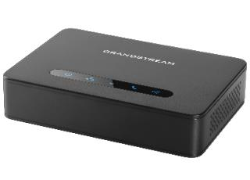
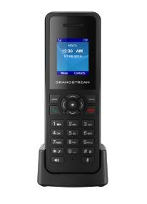
Table 2: DP720 Features in a Glance

DP750/DP720 User Guide | P a g e | 13
DP750 Technical Specifications

The following table resumes all the technical specifications including the protocols / standards supported, voice codecs, telephony features, languages and upgrade/provisioning settings for the Base station DP750.

Table 3: DP750 Technical Specifications


Air Interface

Peripherals

Protocols/Standards

Voice Codecs

Telephony Features

Sample

Applications

QoS

Security

Multi-language

Upgrade/

Provisioning

Multiple SIP

Accounts

Telephony standards: DECT

Frequency bands:
- 1880 – 1900 MHz (Europe), 1920 – 1930 MHz (US)

- 1910 – 1920 MHz (Brazil), 1786 – 1792 MHz (Korea)

- 1893 – 1906 MHz (Japan), 1880 – 1895 MHz (Taiwan)

Number of channels: 10 (Europe), 5 (US, Brazil or Japan), 3 (Korea), 8 (Taiwan) Range: up to 300 meters outdoor and 50 meters indoor

5 LED indicators: Power, Network, Register, Call, DECT

Reset button, Pairing/Paging button

One 10/100 Mbps auto-sensing Ethernet port with integrated PoE

SIP RFC3261, TCP/IP/UDP, RTP/RTCP, HTTP/HTTPS, ARP/RARP, ICMP, DNS (A record, SRV, NAPTR), DHCP, PPPoE, SSH, TFTP, NTP, STUN, SIMPLE, LLDP-MED, LDAP, TR-069, 802.1x, TLS, SRTP, IPv6 (pending)
G.711µ/a-law, G.723.1, G.729A/B, G.726-32, iLBC, G.722, OPUS, G.722.2/AMR-WB (special order), in-band and out-of-band DTMF (in audio, RFC2833, SIP INFO), VAD, CNG, PLC, AJB

Hold, transfer, forward, 3-way conference, downloadable phonebook (XML, LDAP, up to 3000 entries), call waiting, call log (up to 300 records), auto answer, flexible dial plan, music on hold, server redundancy and fail-over
Currency (pending)

Layer 2 QoS (802.1Q, 802.1p) and Layer 3 QoS (ToS, DiffServ, MPLS)
User and administrator level access control, MD5 and MD5-sess based authentication, 256-bit AES encrypted configuration file, TLS, SRTP, HTTPS, 802.1x media access control, DECT authentication & encryption
English, Czech, German, Spanish, French, Hebrew, Nederlands, Japanese, Chinese Simple, Chinese Tradition, Korean, Portuguese, Slovakian, Serbian, Turkish.
Firmware upgrade via TFTP/HTTP/HTTPS, mass provisioning using TR-069 or

AES encrypted XML configuration file

Up to ten (10) distinct SIP accounts per system

Each handset may map to any SIP account(s)

Each SIP account may map to any handset(s)

DP750/DP720 User Guide | P a g e | 14

Ring Group

Power & Green

Energy Efficiency

Package Content

Dimensions

Weight

Temperature

and Humidity

Compliance

Flexible options when multiple handsets share the same SIP account
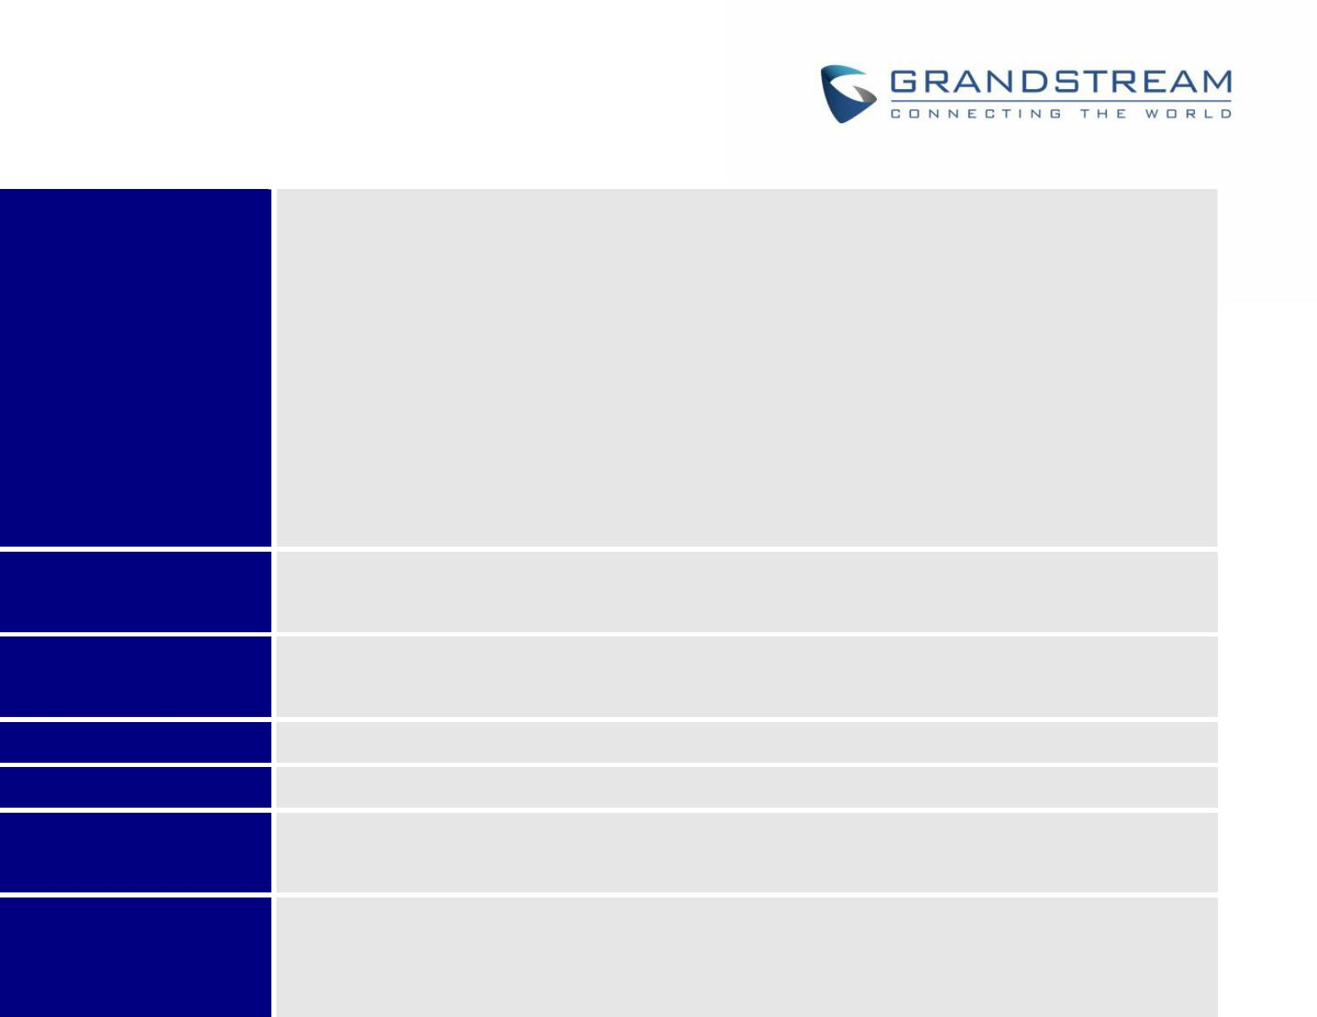
- Circular Mode: all phones ring sequentially, starting with the phone after the one which rang last.

- Linear Mode: all phones ring sequentially in the predetermined order, starting with the first phone each time.

- Parallel Mode: all phones ring concurrently; after one phone answers, the remaining available phones can make new calls

- Shared Mode: all phones ring concurrently and always share the same line (similar to analog phones).

Universal Power Supply Input AC 100-240V 50/60Hz; Output 5VDC, 1A; Micro-USB connection; PoE: IEEE802.3af Class 1, 0.44W–3.84W

Base unit, Universal Power Supply, Ethernet cable, Quick Start Guide, GPL Statement

28.5 mm (H) x 130 mm (W) x 90 mm (D)

Base unit: 143g, Universal Power Supply: 50g; Package: 360g

Operation: -10º to 55ºC (14 to 131ºF); Storage: -20º to 60ºC (-4 to 140ºF);

Humidity: 10% to 90% non-condensing

FCC: Part 15D, 47 CFR 2.1093, Part 15B

CE: EN60950; EN301489-1-6; EN301406

RCM: AS/NZS60950 (Pending)

DP720 Technical Specifications

The following table resumes all the technical specifications including the protocols / standards supported, voice codecs, telephony features, languages and upgrade/provisioning settings for the DP720 handset.

Table 4: DP720 Technical Specifications

 | Air Interface |  |  |  | Telephony standards: DECT
 |  |  |  |  | Frequency bands:
 |  |  |  |  | ▪ | 1880 – 1900 | MHz (Europe), 1920 – 1930 MHz (US)
 |  |  |  |  | ▪ | 1910 – 1920 | MHz (Brazil), 1786 – 1792 MHz (Korea)
 |  |  |  |  | ▪ | 1893 – 1906 | MHz (Japan), 1880 – 1895 MHz (Taiwan)

Number of channels: 10 (Europe), 5 (US, Brazil or Japan), 3 (Korea), 8 (Taiwan) Range: up to 300 meters outdoor and 50 meters indoor

Peripherals 1.8 inch (128x160) color TFT LCD

23 keys including 2 softkeys, 5 navigation / menu keys, 4 dedicated function keys for SEND, POWER/END, SPEAKERPHONE, MUTE

3-color MWI LED 3.5mm headset jack Removable belt clip
Micro-USB port for alternative charging and non-battery operation

DP750/DP720 User Guide | P a g e | 15


 | Protocols/Standards |  |  |  | Hearing Aid Compatibility (HAC) compliant
 | Voice Codecs |  |  |  | G.722 codec for HD audio and G.726 codec for narrow band audio (G.711μ/a-law,
 |  |  |  |  | G.723.1, G.729A/B, iLBC and OPUS are supported via companion DECT base
 |  |  |  |  | station DP750), AEC, AGC, Ambient noise reduction
 | Telephony Features |  |  |  | Hold, transfer, forward, 3-way conference, call park, call pickup, downloadable
 |  |  |  |  | phonebook, call waiting, call log, auto answer, click-to-dial, flexible dial plan,
 |  |  |  |  | music on hold
 | Sample |  |  |  | Currency (pending)
 | Applications
 | HD Audio |  |  |  | Yes, in both Handset and Speakerphone modes
 | Security |  |  |  | DECT authentication & encryption
 | Multi-language |  |  |  | English, Czech, German, Spanish, French, Hebrew, Nederlands, Japanese,
 |  |  |  |  | Chinese Simple, Chinese Tradition, Korean, Portuguese, Slovakian, Serbian,
 |  |  |  |  | Turkish.
 | Upgrade/ |  |  |  | Software Upgrade Over-The-Air (SUOTA), handset provisioning Over-The-Air
 | Provisioning
 | Multiple Line |  |  |  | Each handset may access up to 10 lines
 | Access
 | Power & Green |  |  |  | Universal Power Supply Input AC 100-240V 50/60Hz; Output 5VDC 1A;
 | Energy Efficiency |  |  |  | Micro-USB connection; Rechargeable 800mAh Ni-MH Low Self-Discharge (LSD)
 |  |  |  |  | AAA batteries (250 hours of standby time and 20 hours of talk time)
 | Package Content |  |  |  | Handset unit, universal power supply, charger cradle, belt clip, 2 batteries, Quick
 |  |  |  |  | Start Guide
 | Dimensions |  |  |  | Handset: 155 x 50 x 26 mm, charger cradle: 35 x 63.5 x 54 mm
 | (H x W x D)
 | Weight |  |  |  | Handset: 138g, charger cradle: 71g, universal power supply: 50g; Package: 360g
 | Temperature |  |  |  | Operation: -10º to 50ºC (14 to 122ºF); Charging: 0 to 45ºC (32 to 113ºF); Storage:
 | and Humidity |  |  |  | -20º to 60ºC (-4 to 140ºF); Humidity: 10% to 90% non-condensing
 | Compliance |  |  |  | FCC: Part 15D; 47 CFR 2.1093 & IEEE1528-2013, Part68, Part 15B
 |  |  |  |  | CE: EN60950; EN301489-1-6; EN301406; EN50360; EN62209-1
 |  |  |  |  | RCM: AS/NZS60950; AS/ACIF S040; AS/ACIF S004; AS/CA S004:2013
 |  |  |  |  | (Pending)

DP750/DP720 User Guide | P a g e | 16
GETTING STARTED

This chapter provides basic installation instructions including the list of the packaging contents and also information for obtaining the best performance with the DP720 IP DECT phone and its base station DP750.

Equipment Packaging

 |  |  | Table 5: Equipment Packaging
 |  |  | DP720 |  |  |  |  |  | DP750
 | • | 1 | Handset unit |  |  |  | • | 1 | Base unit
 | • 1 Universal power supply 5V |  |  |  |  |  | • 1 Universal power supply 5V
 | • | 1 | Charger cradle |  |  |  | • | 1 | Ethernet cable
 | • | 1 | Belt clip |  |  |  | • | 1 | Quick start guide
 | • | 2 | Chargeable batteries |  |  |  | • | 1 | GPL Statement

- 1 Quick start guide

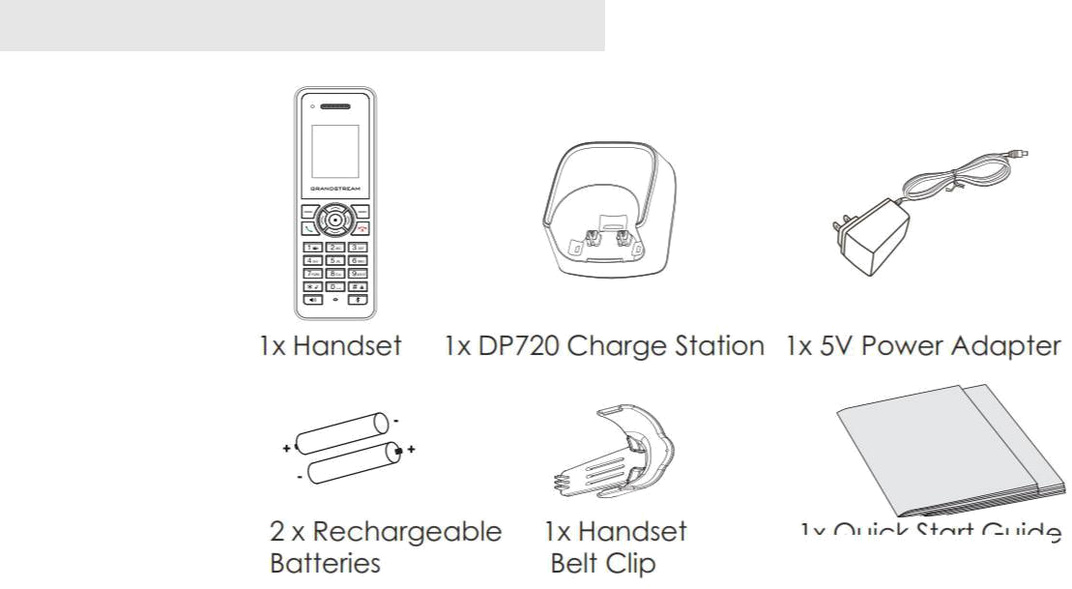

Figure 1: DP720 Package Contents
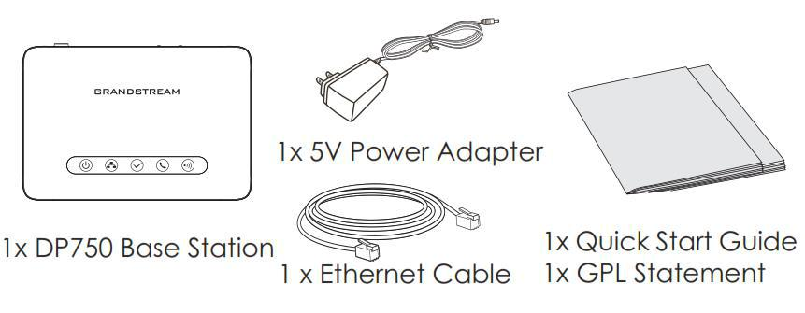

Figure 2: DP750 Package Contents

Note: Check the package before installation. If you find anything missing, contact your system administrator.

DP750/DP720 User Guide | P a g e | 17
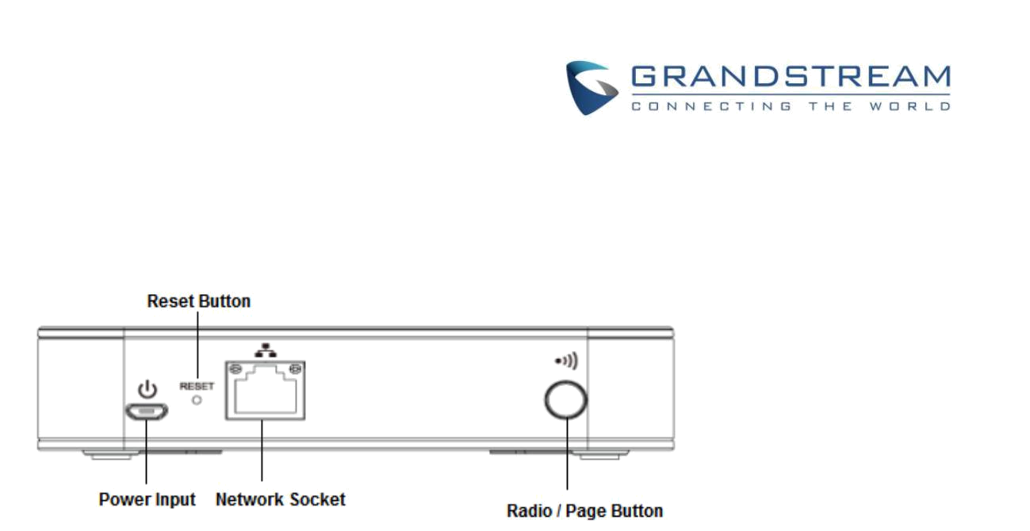
Connecting DP750

To setup the DP750 base station, please follow the steps below:

Figure 3: DP750 Back View

You have two options for power and network connection of the base station: AC power or Power over Ethernet (PoE)

Connecting via AC power

- Connect the micro-USB connector into the related port on the base station and connect the other end of the power adapter into an electrical power outlet.

- Connect the supplied Ethernet cable between the internet port on the base station and the internet port in your network or the switch/hub device port.
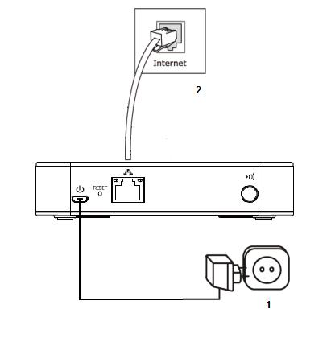

Figure 4: Connecting the Base station

Connecting via PoE

To connect the base station using the POE, you need to connect the Ethernet cable provided (or 3rd party network cable) between the network socket on the base station to Ethernet port of the POE switch/hub.

DP750/DP720 User Guide | P a g e | 18
Setting up DP720 handset

Please follow below steps to insert batteries into the handset:

- Open the battery compartment cover.

- Insert the batteries in the correct polarity.

- Close the battery compartment cover.

Note: Please charge the batteries fully before using the handset for the first time
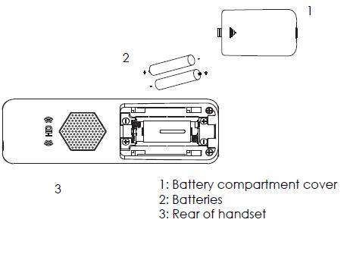

Figure 5: Setting up the DP720

Battery Information

- Technology: Nickel Metal Hydride (Ni-MH)

- Size: AAA

- Voltage: 1.2V

- Capacity: 800mAh

- Charging time: 12 hours from empty to full

- Standby time: up to 250 hours

- Talk time: up to 20 hours active talk time

In order to get the best performance of your DP720 handset, we recommend using original batteries provided in the package or batteries compliant with above specifications.

The specifications may differ depending on the age and capacity of the batteries used.

Important Note: Be careful when inserting the batteries into your handset to avoid any risk of short-circuits which lead to damage your batteries and/or the handset itself. Do not use damaged battery which can increase the risk of serious harm.

DP750/DP720 User Guide | P a g e | 19
Setting up the Charge Station

Please refer to the following steps for setting up the charge station and charging the handset:

- Connect the DC plug on the power adapter to the micro-USB connector on the charge station.

- Connect the other end of the power adapter into an electrical power outlet.

- After setting up the handset and charger station, place the handset in the charger station.
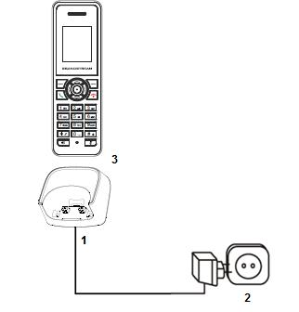

Figure 6: Setting up the charger station

DP750 LED Patterns

The DP750 has 5 LED lights on it. Please see on the following table the meaning of each light.


Table 6: DP750 Led Patterns
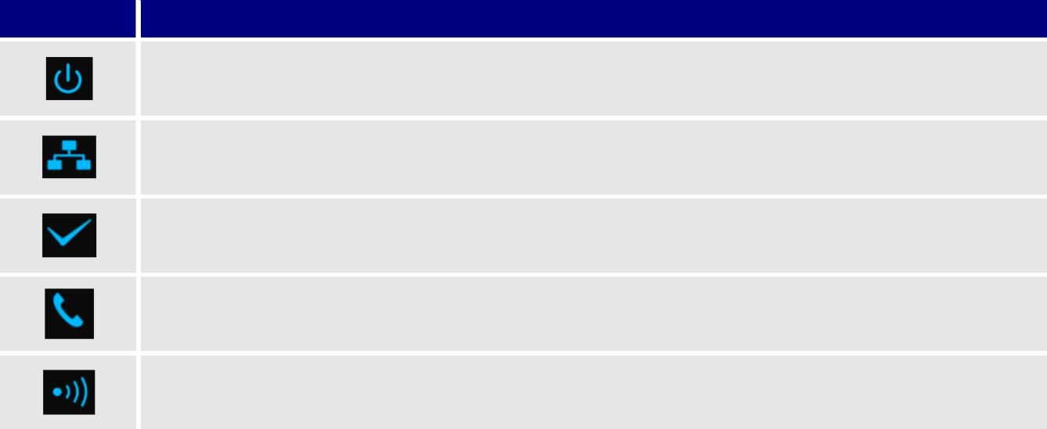
LED Light Status

Indicates power ON/OFF

Indicates access to the Network. Remains ON while there is Access to the Network

Indicates if a SIP account is registered

Indicates status of the lines.

Blinking: A line is in use. Solid ON: All lines are free.

The radio icon for pairing the DP720 and DP750, if we keep pressing the radio button it starts blinking indicating pairing attempt.

DP750/DP720 User Guide | P a g e | 20
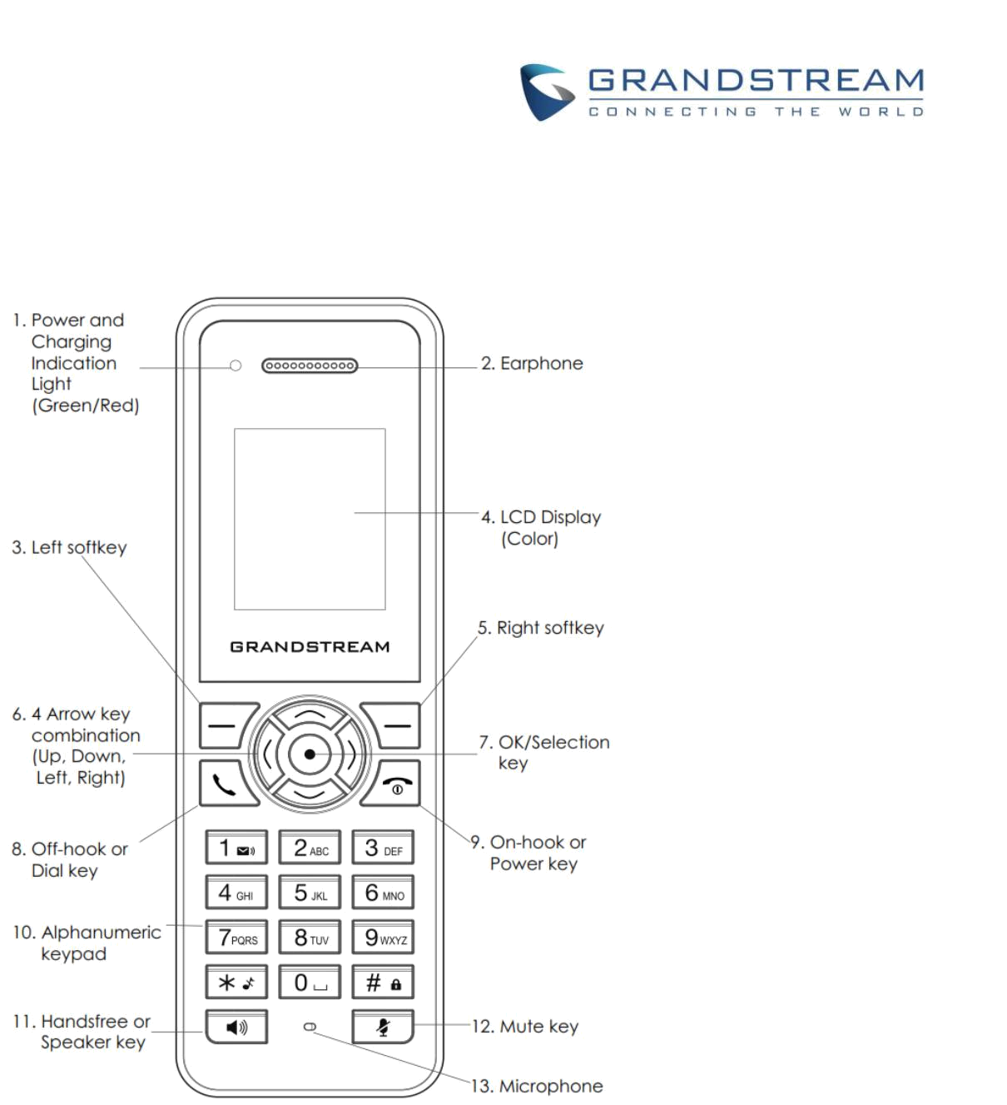
DP720 Handset Description

The LCD screen and the keypad are the main hardware components of the DP720.

 |  |  |  |  |  |  |  |  | Figure 7: Handset Keys Description
 |  |  |  |  |  |  |  |  | Table 7: Handset Keys Description
 |  |  |  |  | Key |  |  |  | Description
 | 1. |  |  |  | Power and Charging |  |  |  | Red: Charging. Green: Charge completed.
 |  |  |  |  | Indication Light |  |  |  | Blinking: Missed call(s) or Voice Mail received.
 | 2. |  |  |  | Earphone |  |  |  | Delivers audio output.
 | 3,5 |  |  |  | Left and right softkeys |  |  |  | Correspond to functions displayed on the LCD. These functions
 |  |  |  |  |  |  |  |  | change depending on the current context.
 | 4. |  |  |  | LCD display |  |  |  | Shows call information, handset status icons, prompt messages, etc.
 | 6. |  |  |  | 4 Arrow key |  |  |  | Permits navigation of the cursor through the displayed menu options.
 |  |  |  |  | combination
 | 7. |  |  |  | OK/Selection key |  |  |  | Selects the option chosen by the cursor. (Enters the main menu from
 |  |  |  |  |  |  |  |  | the home screen.)
 | 8. |  |  |  | Off-hook / Dial key |  |  |  | Enters dialing mode, or dials number entered.

DP750/DP720 User Guide | P a g e | 21
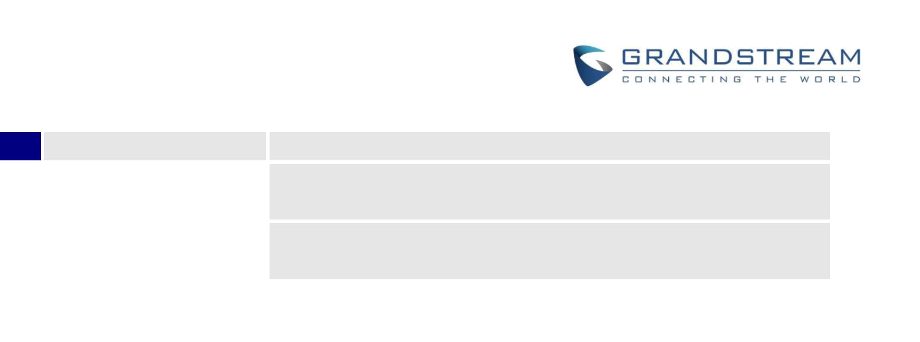
- On-hook / Power keyTerminates calls, or turns the handset on / off.

- Alphanumeric KeypadProvides the digits, letters, and special characters in context-sensitive


applications. For + sign, press and hold key 0.
- Hands-free / Speaker Switches between handset and hands-free / speaker modes. key

 | 12. |  |  |  | Mute key |  |  |  | Activates or deactivates the mute feature.
 | 13. |  |  |  | Microphone |  |  |  | Picks up audio earpiece and hands-free calls.

DP720 Icons Description

The following table contains the description of each icon that might be displayed on the screen of DP720.

Table 8: DP720 Icons Descriptions
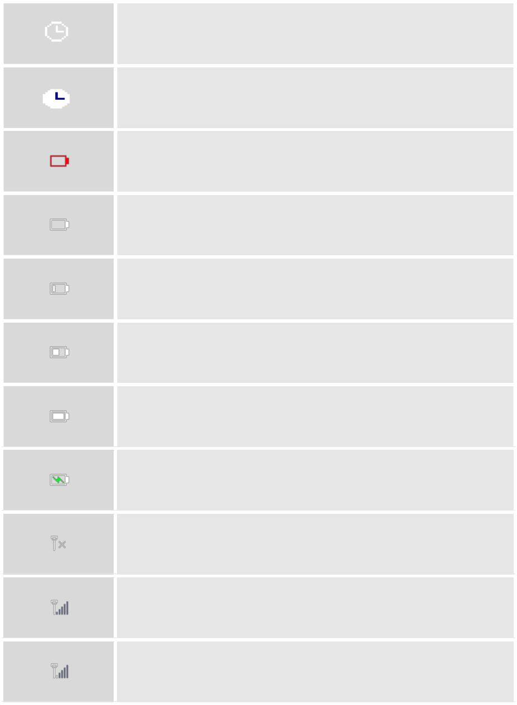
Alarm

Alarm icon. The icon shows when set alarm.

Snooze

Snooze icon. The icon shows when set snooze.

Battery status

Not equipped with battery

Battery status

Battery empty

Battery status

Battery low

Battery status

Battery normal

Battery status

Battery full

Battery status

Charging

Signal status

Not subscribed

Signal status

Not in range

Signal status

Signal very low

DP750/DP720 User Guide | P a g e | 22
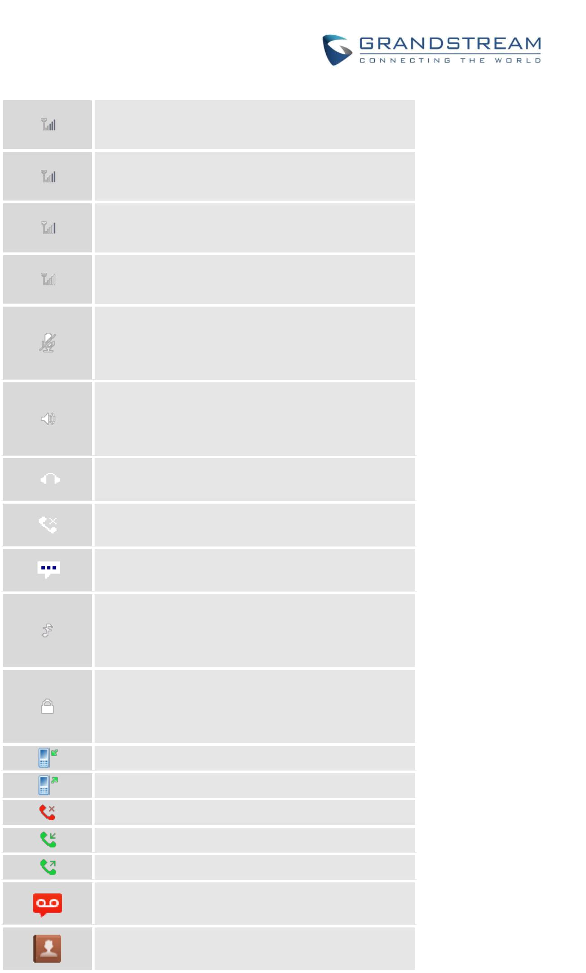
Signal status

Signal low

Signal status

Signal normal

Signal status

Signal good

Signal status

Signal very good

Microphone MUTE Status

OFF - Not muted

ON – Muted

Speaker status

OFF - Speaker is inactivated

ON - Speaker is activated

Headset icon

Missed Call icon

Voicemail icon

Ringtone status

OFF - Ringtone off (Silent mode)

ON - Ringtone on

Keypad Lock status

OFF - Keypad unlock

ON - Keypad locked

Incoming Call notification

Outgoing Call notification

Missed Call notification

Incoming Call notification

Outgoing Call notification

Voicemail notification

Contacts

DP750/DP720 User Guide | P a g e | 23
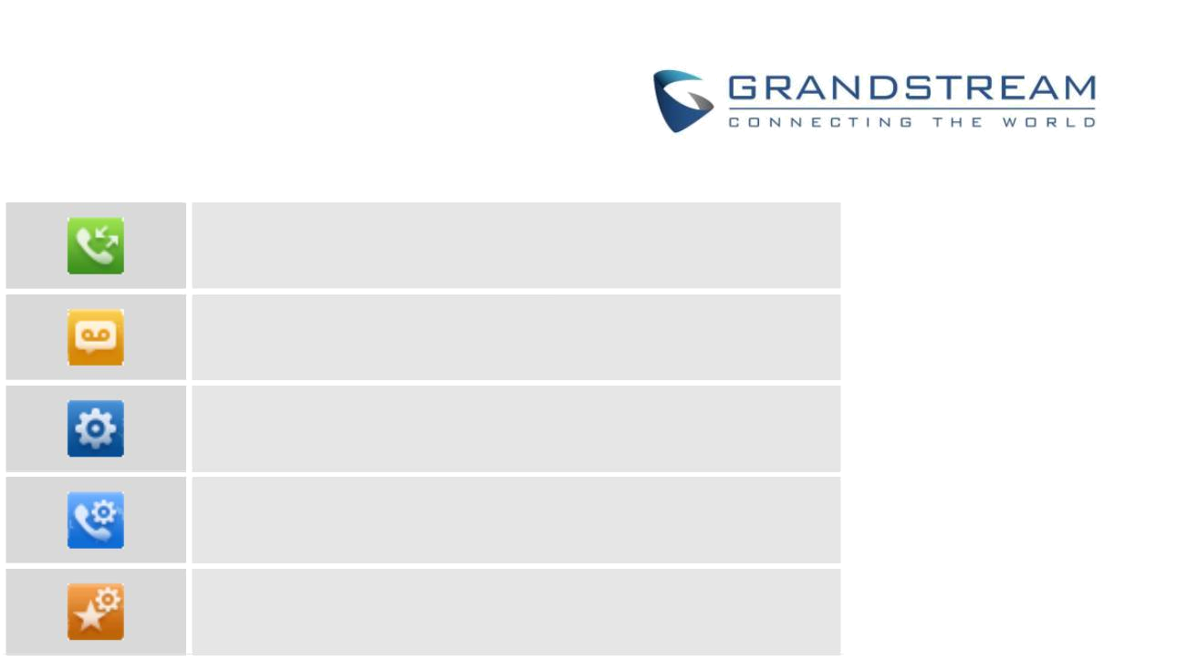
Call History

Voice Mail

Settings

Call Settings

Tools

DP750/DP720 User Guide | P a g e | 24
DP720 Handset Menu

The handset has an easy-to-use menu structure. Every menu opens a list of options. To open the main menu, press “Menu” (left softkey) when the handset is on and in standby mode. Press Arrow keys to navigate to the menu option you require. Then press “Select” (left softkey) or OK/Selection key to access further options or confirm the setting displayed. To go to the previous menu item, press “Back” (right softkey). You can press Power key at any time to cancel and return to standby mode. If you do not press any key, the handset automatically reverts to standby mode after 20 seconds.
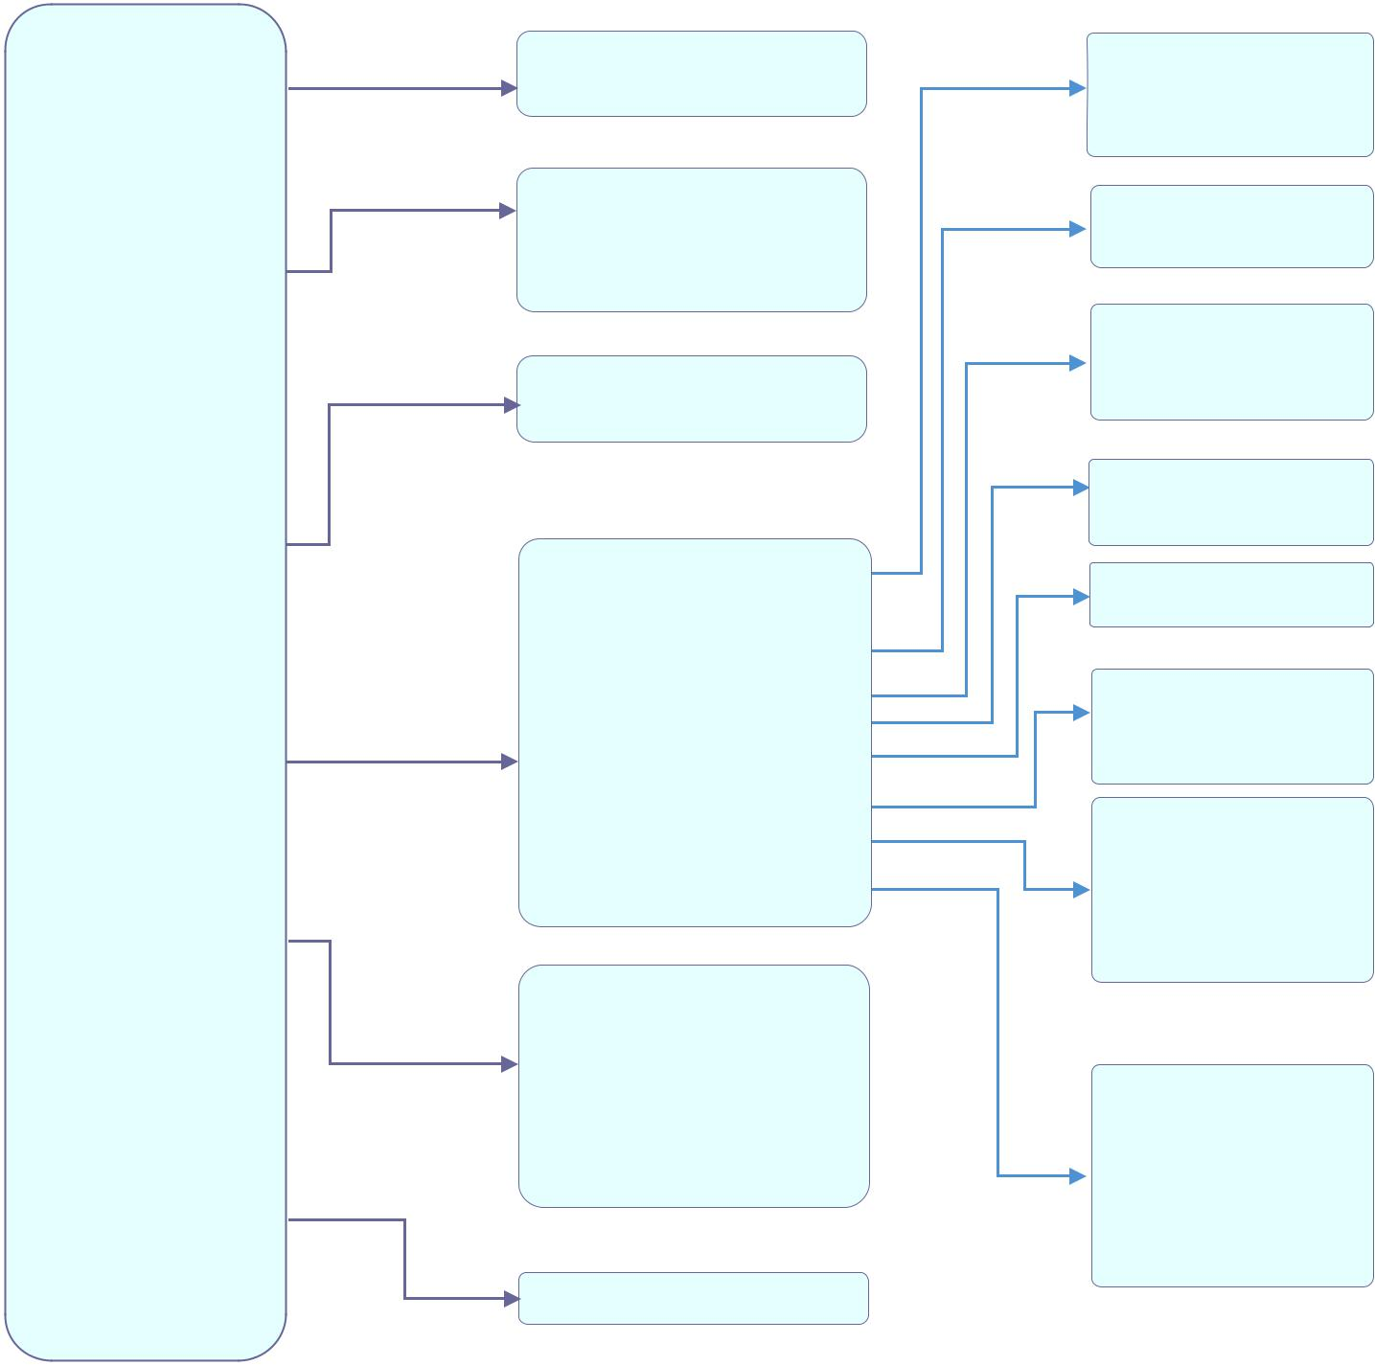

Contacts

Call History

Voice Mail

Settings

Call Settings

Tools

Private
Shared

Missed Calls
Accepted Calls
Outgoing Calls
All calls

Play Message
Set Voice Mail

Registration
Handset Name
Phone Language
Date / Time
Audio
Display
Network Settings
Sip Settings
System Settings
Firmware Upgrade
Factory Functions
Status

Do Not Disturb
Call Waiting
Call Forward
Speed Dial
Outgoing Default Line
Auto Answer
Lines

Alarm

Register
Deregister
Select Base

Time
Date

Advisory Tone
Ringtones
Volume

Backlight Timeout
Menu Key Timeout

IP Settings

Change Base PIN
Factory Reset
Reboot Base

Diagnostic Mode
Audio Loopback
LCD ON /OFF
LCD Diagnostic
System Monitoring

Model(RF)
Firmware(BS)(HS)
IP Address
Subnet Mask
Gateway
MAC Address
IPEI

Figure 8: DP720 Menu Structure

DP750/DP720 User Guide | P a g e | 25


 |  |  | Contacts |  |  |  | • | Private: Private contacts include contacts visible in the current handset
 |  |  |  |  |  |  |  | only. You can add, edit, delete, and call all the entries in private contacts.
 |  |  |  |  |  |  | • Shared: Shared contacts are the contacts shared between the handsets
 |  |  |  |  |  |  |  | subscribed to the DP750 base station. You can add, edit, delete, edit and
 |  |  |  |  |  |  |  | call all the entries in shared contacts as well.
 |  |  | Call History |  |  |  | Display the call history: Missed Calls, Accepted Calls, Outgoing Calls or All
 |  |  |  |  |  |  | Calls. You can add contacts to Shared Contacts directly from call logs.
 |  |  | Voice Mail |  |  |  | • | Play Message: Play the voice mail messages received.
 |  |  |  |  |  |  | • Set Voice Mail: Configure the voice mail parameters.
 |  |  | Settings |  |  |  | • | Registration
 |  |  |  |  |  |  |  | Register and unregister your handset and also search for base station.
 |  |  |  |  |  |  | • | Handset Name
 |  |  |  |  |  |  |  | Change the handset’s name.
 |  |  |  |  |  |  | • | Phone Language
 |  |  |  |  |  |  |  | Select the language to be displayed on the phone's LCD. (Default is
 |  |  |  |  |  |  |  | English.)
 |  |  |  |  |  |  | • | Date/Time
 |  |  |  |  |  |  |  | Configure date and time on the handset.
 |  |  |  |  |  |  | • | Audio
 |  |  |  |  |  |  |  | Specify ringtones for incoming calls, the volume, and advisory tones
 |  |  |  |  |  |  |  | (keypad, confirmation, low battery notifications).
 |  |  |  |  |  |  | • | Display
 |  |  |  |  |  |  |  | Configure backlight timeout.
 |  |  |  |  |  |  | • | Network Settings
 |  |  |  |  |  |  |  | Configure IP addresses and select DHCP/Static IP mode.
 |  |  |  |  |  |  | • | SIP Settings
 |  |  |  |  |  |  |  | Configure/View SIP accounts settings.
 |  |  |  |  |  |  | • | System settings
 |  |  |  |  |  |  |  | Change base PIN code; Perform factory reset.
 |  |  |  |  |  |  | • | Firmware Upgrade
 |  |  |  |  |  |  |  | Upgrade the firmware version of the handset.
 |  |  |  |  |  |  | • | Factory Functions
 |  |  |  |  |  |  |  | - | Diagnostic Mode
 |  |  |  |  |  |  |  |  | All LEDs will light up, and the LCD will display a table listing the
 |  |  |  |  |  |  |  |  | names of all keys in red. Press any key to diagnose; the key's name
 |  |  |  |  |  |  |  |  | will display in blue. After all keys are diagnosed, a prompt message
 |  |  |  |  |  |  |  |  | (“PASS”) will display; press “Back” (right softkey) to exit.
 |  |  |  |  |  |  |  | - | Audio Loopback
 |  |  |  |  |  |  |  |  | Speak to the phone using speaker/handset/headset. If you can hear
 |  |  |  |  |  |  |  |  | DP750/DP720 User Guide | P a g e | 26

 |  |  |  |  |  |  |  | your voice, your audio is working fine. Press “Exit” softkey to exit
 |  |  |  |  |  |  |  | audio loopback mode.
 |  |  |  |  |  |  | - LCD ON / OFF
 |  |  |  |  |  |  |  | Select this option to turn off LCD. Press any button to turn on LCD.
 |  |  |  |  |  |  | - | LCD Diagnostic
 |  |  |  |  |  |  |  | Select this option to enter LCD Diagnostic mode. Press
 |  |  |  |  |  |  |  | “Next” (left softkey) to display white screen. Continue pressing the left
 |  |  |  |  |  |  |  | softkey to view all remaining screens (black, blue, red, and green) and
 |  |  |  |  |  |  |  | then exit. End the test early by pressing the right softkey.
 |  |  |  |  |  |  | - | System Monitoring
 |  |  |  |  |  |  |  | Displays the RSSI and battery voltage information.
 |  |  |  |  |  | • | Status
 |  |  |  |  |  |  | Display the handset status (Firmware, Model, Hardware, IPEI …)
 |  | Call Settings |  |  |  | • | Do Not Disturb
 |  |  |  |  |  |  | Enable/disable do not disturb mode on the phone.
 |  |  |  |  |  | • | Call Waiting
 |  |  |  |  |  |  | Configure call waiting feature.
 |  |  |  |  |  | • | Call Forward
 |  |  |  |  |  |  | Configure call forward feature.
 |  |  |  |  |  | • | Speed Dial
 |  |  |  |  |  |  | Assign the numbers for speed dial.
 |  |  |  |  |  | • | Outgoing Default Line
 |  |  |  |  |  |  | Select outgoing default line.
 |  |  |  |  |  | • | Auto Answer
 |  |  |  |  |  |  | Enable/disable auto answer feature.
 |  |  |  |  |  | • | Lines
 |  |  |  |  |  |  | Display the line status.
 |  | Tools |  |  |  | • | Alarm
 |  |  |  |  |  |  | - | Set Alarm:
 |  |  |  |  |  |  |  | Configure the alarm
 |  |  |  |  |  |  | - | Alarm Settings:
 |  |  |  |  |  |  |  | Configure Alarm Settings (Alarm Volume, Alarm Tone, Snooze Time)

DP750/DP720 User Guide | P a g e | 27
BASIC OPERATIONS

Turning the Handset ON / OFF

To turn ON the handset

- Long press on Power key  until the LCD screen lights up.

To turn OFF the handset

- Long press on Power key again when the handset is idle until the display turns off.

Register DP720 Handset to DP750 Base Station

- On DP750 Base station, press and hold the Radio/Page button for 7 seconds until the Radio icon starts blinking to start the subscription process. Or Access web UI, go to Status >DECT Status and press Subscribe button to Open Subscription.
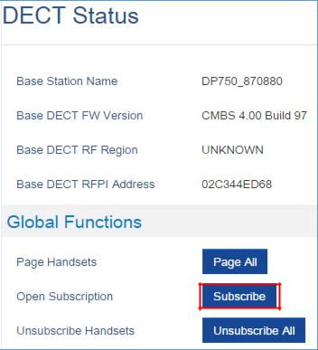

Figure 9: DECT Status - Subscribe

- On DP720, Press “Menu” (left softkey  or the selection key  ) to bring up operation menu.

- Press Arrow keys to move the cursor to Settings and navigate to Registration, then press “Select” (left softkey ).

DP750/DP720 User Guide | P a g e | 28
- Navigate to Register, then press “Select” while the DP750 Radio icon is blinking.

- Select BaseX (X=1-4) corresponding to the desired base station DP750, then press Subscribe.

- The DP720 will search for nearby base stations and will display the RFPI code and base station name of the discovered DP750.

- Press Subscribe to pair with the displayed DP750.

- The DP720 will display Easy Pairing on the LCD and play an audible buzz when successful. Then it will return to the home screen, displaying the handset name and number assigned by the registered base station.
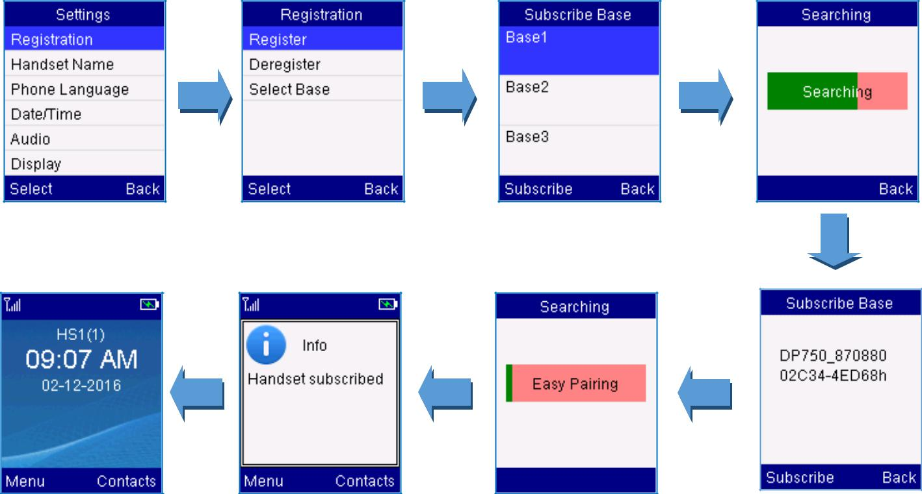

Figure 10: Registration process

Using DP720 with multiple DP750 base stations

DP720 handset can be registered with up four different DP750 base stations.

Registering DP720 to an additional DP750 base station

Considering DP720 is previously registered to an initial base station, please follow below steps to register a handset to an additional base station:
- Press Menu (left softkey  or the selection key  ) to bring up operation menu.

- Use arrow keys to reach Settings and select Registration.

DP750/DP720 User Guide | P a g e | 29
- Select Register.

- Navigate to an unsubscribed Base using arrow keys, and click on Subscribe.

- Make sure that the subscription is opened on the new base station.
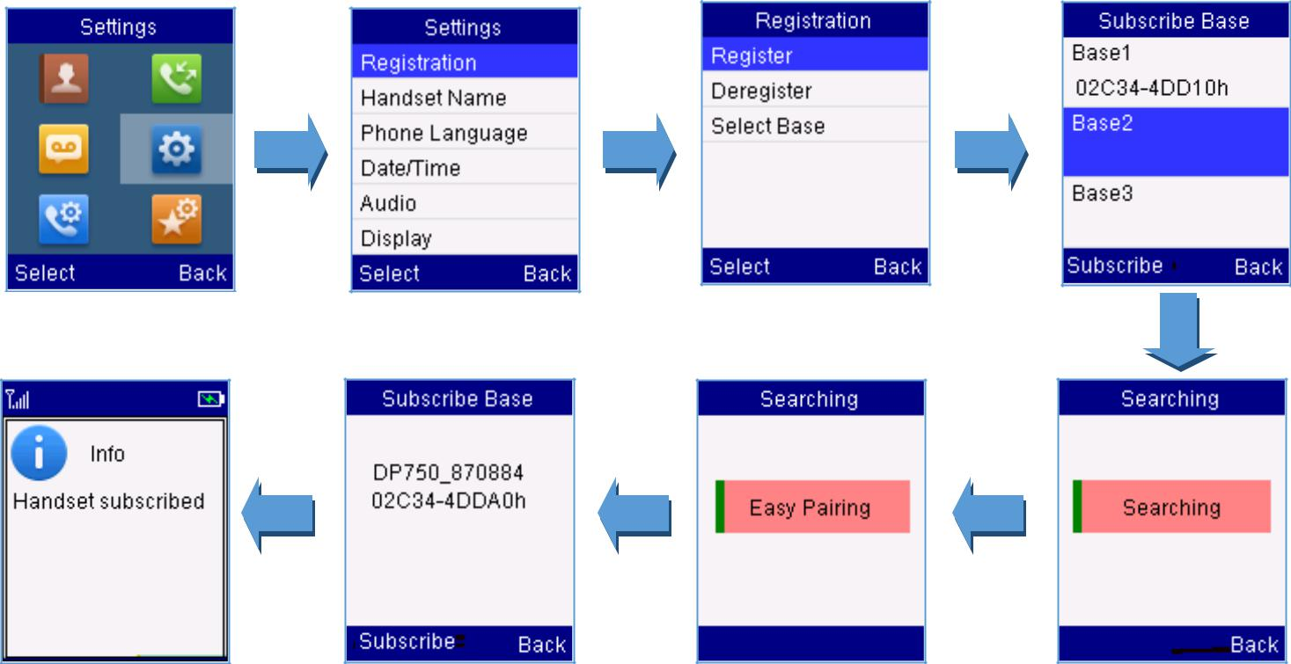

Figure 11: Multiple Base Stations Registration

Switching between different base stations

- Press Menu (left softkey or the selection key ) to bring up operation menu.

- Use arrow keys to reach Settings .

- Select Registration.

- Navigate to Select Base using arrow keys.

- Select the desired base station and press Select.
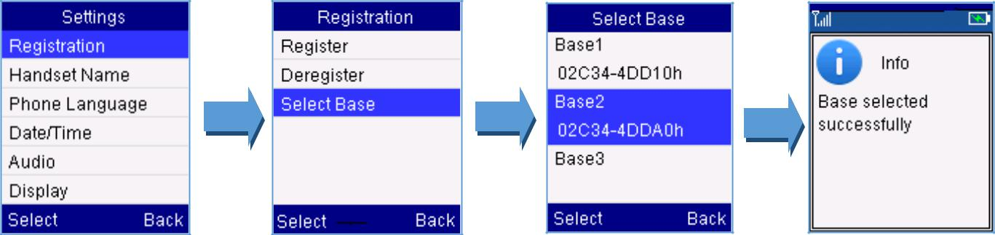

Figure 12: Switching Between Base Stations

DP750/DP720 User Guide | P a g e | 30

Unregister the DP720

1. On DP720, press “Menu” (left softkey  or the selection key ) to bring up operation menu.

- Press arrow keys to move the cursor to Settings and then press “Select”.

- Navigate to Registration, then press “Select” (left softkey ).

- Navigate to Deregister.

- Select the Handset to be unregistered and press “Deregister” (left softkey ).

- Enter the system PIN code (default: 0000).

- Press “Done” (left softkey  ) to confirm or “Back” (right softkey  ) to cancel.

Obtain DP750 Base Station IP Address via paired DP720

DP750 is by default configured to obtain IP address from DHCP server where the unit is located. In order to know which IP address is assigned to your DP750, please follow below steps using a paired DP720 handset with your DP750 base station.

Please see Register DP720 Handset to DP750 Base Station

- Press Menu (left softkey or the selection key ) to bring up operation menu.

- Press Arrow (Up, Down, Left, Right) keys to move the cursor to Settings , then press “Select” (left softkey  ).

- Press up arrow key to navigate to Status, then press “Select”.
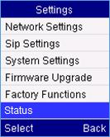

- The LCD screen will display information about the DP720.

- Using arrow keys, navigate down to view the IP address of the DP750.
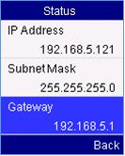

DP750/DP720 User Guide | P a g e | 31
Setting the Key Lock

You can lock the keypad against unintentional entries. It is, however, still possible to pick up incoming calls

even with the keypad locked.

- To enable the Keypad Lock

  - Press the Pound key “#”  and hold for approximately 2 seconds.

  - The display shows Keypad Locked briefly and the key lock icon appears in the display.

- To disable the Keypad Lock

  - Press and hold Pound key “#”  to unlock the keys.

  - Keypad Unlocked appears briefly in the display and a windows prompt will be displayed to confirm that the keypad is unlocked.

Locating a DP720 Handset from DP750 Base station

In some situations, you may have a DP720 handset incorrectly positioned and you don’t know its current location. You can locate a DP720 handset from his registered DP750 base station using below steps:

Locate via DP750 Web UI

- Access your DP750 base station web UI by entering its IP address in your favorite browser.

- Enter your admin’s username and password (default username and password: admin/admin).

- Press Login to access your settings.

- Go to Status > DECT Status tab.

- Choose which handset to locate and press its corresponding Page button.

- A paging call will be received on the selected DP720 handset.

If you press Page All, all registered DP720 handsets will be receiving paging call.

7. Once located, you can press any key on the handset or press Page or Page All to end paging call.

EU

DP750/DP720 User Guide | P a g e | 32
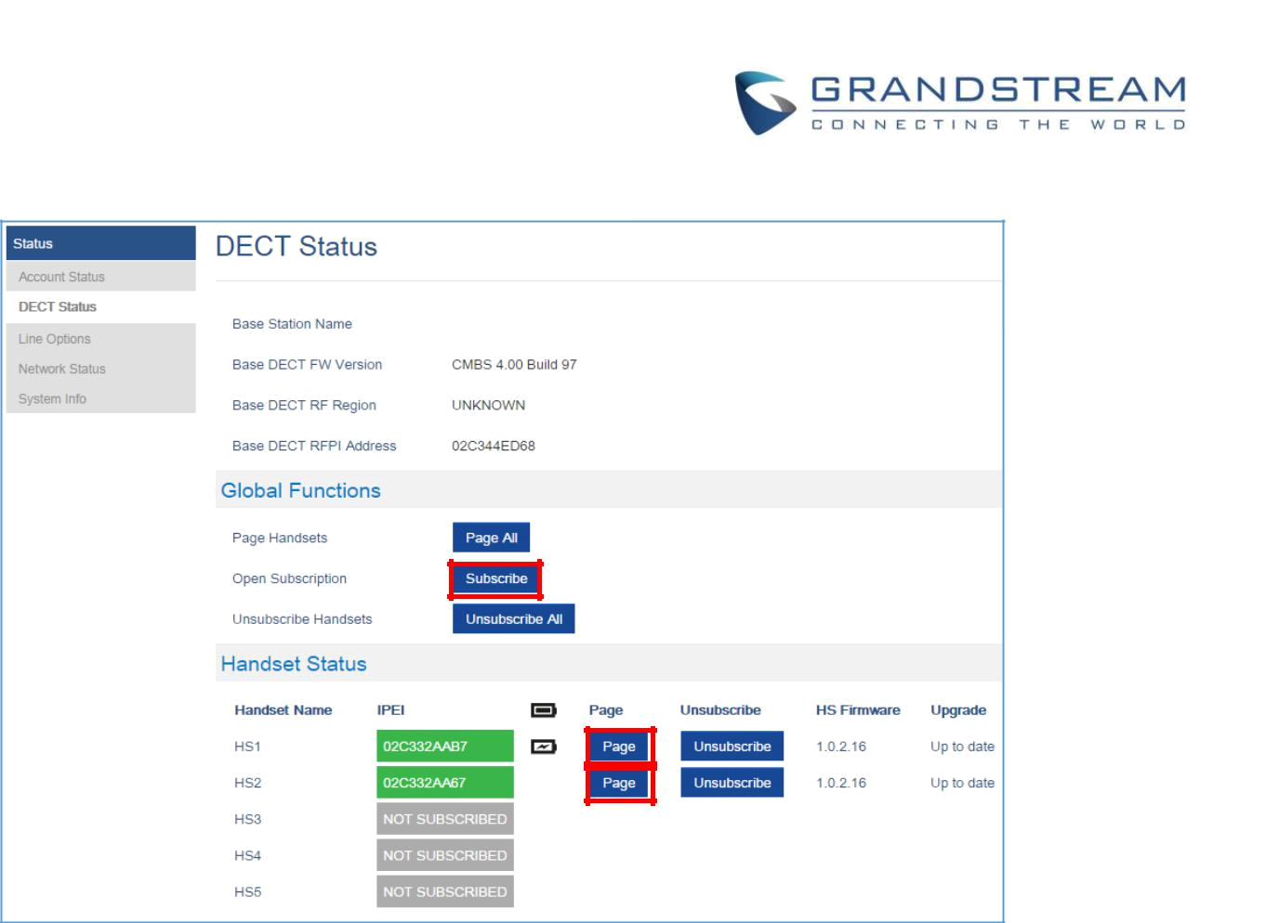

Figure 13: Locate Handset via Web UI

Locate via DP750 Base station

- On DP750 Base station back side, press Radio/Page button  .

- All registered handsets will receive paging call, once located, you can terminate the paging calling by pressing any key on the handsets or the radio/page button again.

Checking System Status

You can view the system status on your handset including the following information of the system:

 |  |  |  | Table 9: DP720 Info description
 | Item |  |  | Description
 | Model |  |  | Product model info. DP720
 | Firmware |  |  | Current firmware version installed on DP720. i.e.: 1.0.2.4
 | Hardware |  |  | Hardware version of DP720. i.e.: 1.4A
 | IPEI |  |  | International Portable Equipment Identifier.
 |  |  |  | Unique “serial number” for DECT handsets.
 | DECT Region |  |  | Region of DECT. i.e. EU or US
 | IP Address |  |  | IP address of the base station DP750 if registered.
 | Subnet Mask |  |  | Subnet Mask of the base station DP750 if registered.
 | Gateway |  |  | Gateway IP of the base station DP750 if registered.
 | MAC address |  |  | MAC address of the base station DP750 if registered.
 |  |  |  | DP750/DP720 User Guide | P a g e | 33

To check the handset status

1. Press Menu (left softkey  or the selection key ) to bring up operation menu.

- Use arrow keys to reach Settings .

- Browse sub-menus until reaching Status sub-menu and press Select.

Basic Network Settings

Once connected to the network the base station attempts to contact a DHCP server to obtain valid network settings (e.g., IP address, subnet mask, gateway address and DNS address) by default.

The users could also configure basic network settings manually. In order to configure the network settings manually, please follow the steps bellow:

- Press Menu (left softkey or the selection key ) to bring up operation menu.

- Use arrow keys to reach Settings .

- Navigate to select Network Settings.

- Enter the system PIN code (default: 0000) and press the softkey “Save” (left softkey ).

- To change to static IP, press or to select Static from the IP Settings field.

- Enter valid values in the IP Address, Subnet Mask, Gateway, DNS Server fields.

- Press softkey “Save” ( ) to save and apply the new changes.

A message prompt message will be displayed to confirm that the new settings are saved successfully.
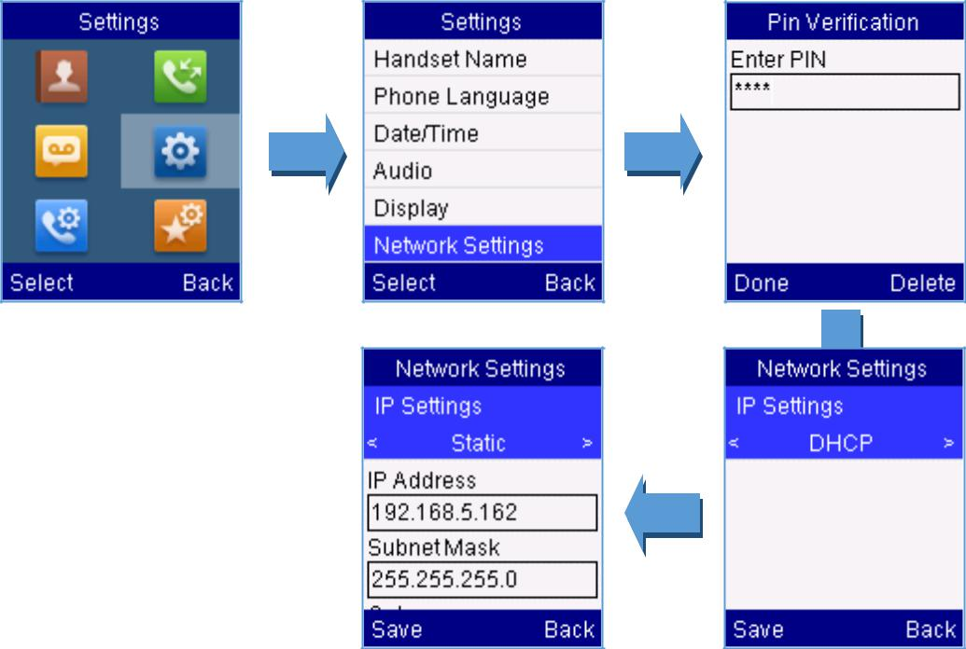

Figure 14: Network Settings configuration

DP750/DP720 User Guide | P a g e | 34
Register a SIP Account

DP750 supports up to 10 SIP accounts, 5 handsets. Each handset can be configured up to 10 accounts.

Please be aware that line settings will be affected by DID settings (hunting group settings) in “DECT - SIP Account Settings”.

Register account via web user interface

- Access your DP750 base station web UI by entering its IP address in your favorite browser.

- Enter your admin’s username and password (default username and password: admin/admin).

- Press Login to access your settings.

- Go to Profiles tab and select a profile to use.

DP750 supports up to 4 profiles. A profile is a set of settings including general settings, network settings, SIP setting, audio setting, call settings and ring tones, and etc.

A profile can be used with different SIP accounts.

- In General Settings, set the following:

  - Profile Active to Yes.

  - SIP Server field with your SIP server IP address or FQDN.

  - Failover SIP Server with your failover SIP server IP address or FQDN. Leave empty if not available.

  - Prefer Primary SIP Server to No or Yes depending on your configuration. Set to No if no failover SIP server is defined. If “Yes”, account will register to primary SIP server when failover registration expires.

  - Outbound Proxy with your outbound proxy IP address or FQDN. Leave empty if not available.

- Press Save and Apply to save your configuration.

- Go to DECT >SIP Account Settings
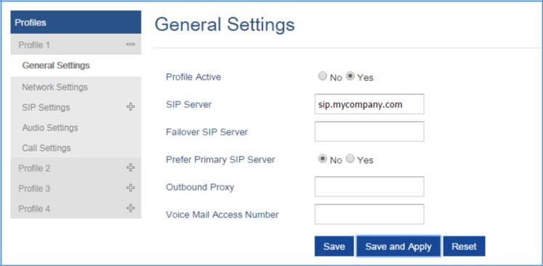

Figure 15: SIP Settings

DP750/DP720 User Guide | P a g e | 35
- Configure your SIP details in desired account:

  - Account: Select Account row to configure (Account 1 – Account 10).

  - SIP User ID: User account information, provided by VoIP service provider (ITSP). Usually in the form of digit similar to phone number or actually a phone number.

  - Authenticate ID: SIP service subscriber’s authenticate ID used for authentication. Can be identical to or different from SIP User ID.

  - Password: SIP service subscriber’s account password to register to SIP server of ITSP. For security reasons, the password will field will be shown as empty.

  - Name: Any name to identify this specific user.

  - Profile: Select the corresponding Profile ID (1/2/3/4).

  - HS Mode: Assign the account to specific handset (HS1, HS2…) or hunting group mode.

  - Active: Set to Yes. If set to No, account is disabled and will not register.

- Press Save and Apply to save your configuration.
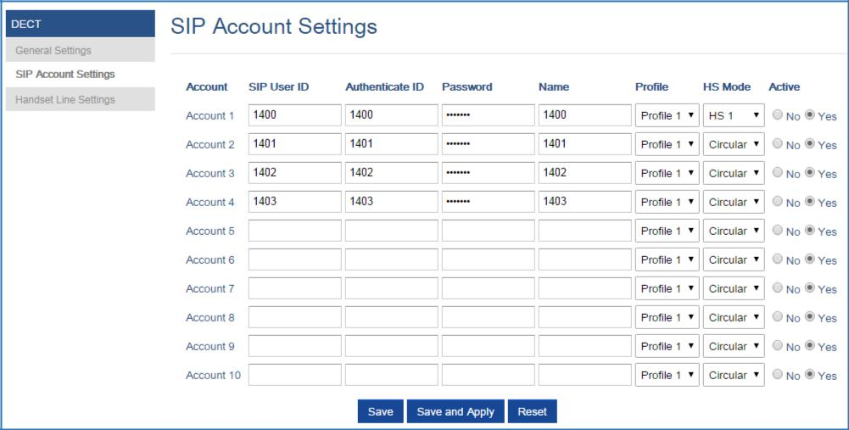

Figure 16: Sip Accounts Settings

After applying your configuration, your phone will register to your SIP Server.

You can verify if your DECT phone has registered with your SIP server from your DP750 web interface under Status > Account Status (a green background with Yes under SIP Registration column for corresponding account indicates the account has been successfully registered).

DP750/DP720 User Guide | P a g e | 36
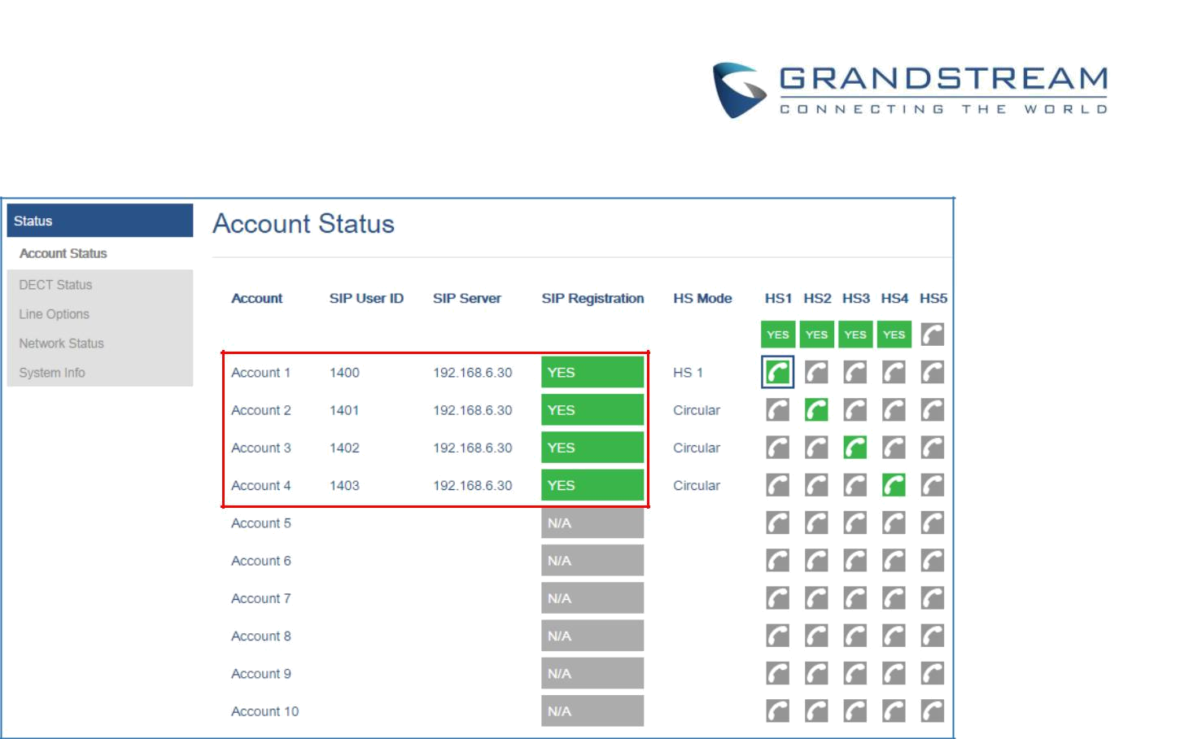

Figure 17: Account Status

Return to Idle Screen

Press the Power Key  to quickly exit the menu and return back to the main idle screen.

If you do not press any key in a period of time, the LCD screen will automatically exit the menu and return to the idle screen as well.

When you are navigating on the handset’s menu, and you receive an incoming call, the LCD screen will automatically exit the menu and you can either accept or reject the call, when the call is terminated, the LCD screen will return back to the idle screen.

Change Menu and Backlight Timeout

- Press Menu (left softkey or the selection key ) to bring up operation menu.

- Use arrow keys to reach Settings .

- Navigate to Display, and then press “Select” (left softkey ).

- Set desired time in seconds for Backlight timeout and for Menu timeout. Available value: 15 seconds, 30 seconds, 60 seconds or disabled. (default is 30 seconds)

DP750/DP720 User Guide | P a g e | 37
PHONE SETTINGS

This chapter will help you with the instruction for configuring and changing the settings of your DP720,

Editing the Handset’s name

The procedure for changing the name of your handset shown in the display in standby mode is as follows:

- Press Menu (left softkey or the selection key  ) to bring up operation menu.

- Use arrow keys to reach Settings .

- Navigate to select Handset Name, and then press “Select” (left softkey  ).

- Enter the desired name and press “Rename” (left softkey ) and then the DP720 will display a confirmation message that the rename operation was successful.
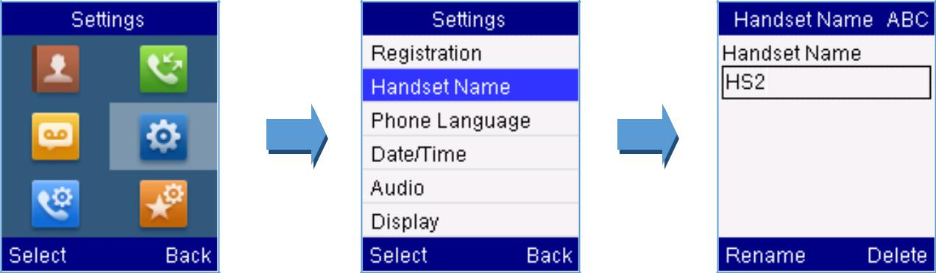

Figure 18: Handset Name editing

Changing the Base PIN Code

Users can change their code PIN by following the steps bellow:

- Press Menu (left softkey or the selection key ) to bring up operation menu.

- Use arrow keys to reach Settings .

- Navigate to select System Settings, and then press “Select” (left softkey ).

- Enter the current code PIN (By Default is 0000), a new window will be displayed inviting you to enter the new password, when done press “Save” (left softkey  ) and a prompt message will be displayed to confirm that the new code PIN has been saved successfully.

DP750/DP720 User Guide | P a g e | 38
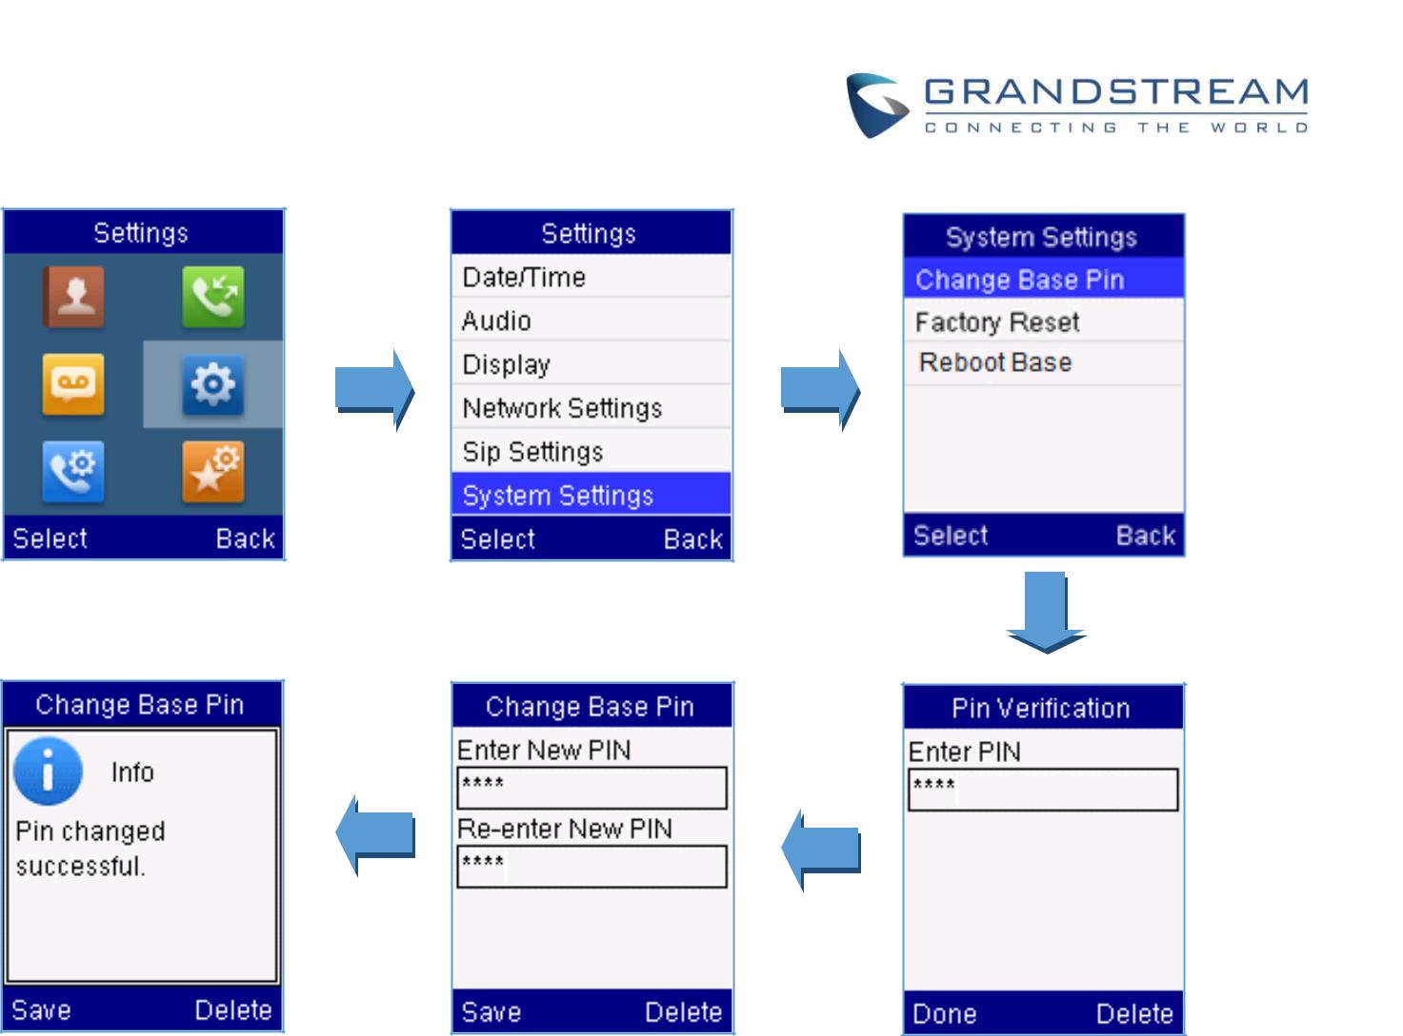

Figure 19: Changing Admin Base PIN Code

Selecting the Menu Language

The DP720 supports displaying texts in different languages. The handset supports 27 languages (see the table of the technical specifications). The default language of the handset is English. You can change the language according to your requirement. To change the language of the handset, please proceed as follows:

- Press Menu (left softkey or the selection key ) to bring up operation menu.

- Use arrow keys to reach Settings .

- Navigate to select Phone language, then select the desired language and press “Select” (Left softkey ). The LCD screen prompts “Change phone language to xxx (xxx it’ the language you selected)”

- Press “Yes” (left softkey ) to accept the change. Text displayed on the handset will change to the selected language.

DP750/DP720 User Guide | P a g e | 39
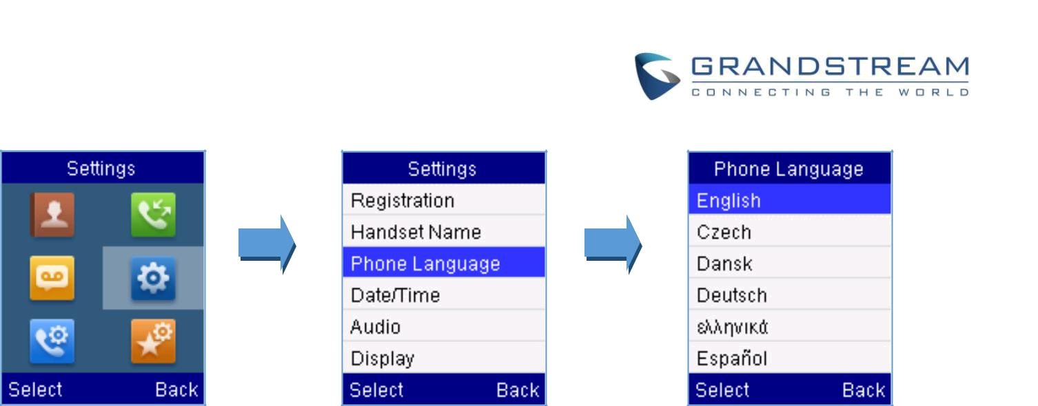

Figure 20: Handset Language

Activate/Deactivate Hands-Free Mode

This function allows you to make a call without having to hold the handset in your hand.

- Press the Hands free key  while you are making a call or on the idle screen to activate hands free mode.
- Press the Hands free key  again to deactivate the hands free function.

Muting the Microphone

Press the Mute key  to switch off the microphone during an established call. You can now talk freely

without the other party hearing you and the icon of mute will be displayed on the screen. Press the

Mute key again to switch the microphone back on.

Adjusting Speaker and Earpiece Volume

Press left key | or right key | while you are on an established call to set the volume of the earphone /
speaker. You can choose between 5 different levels. The default level is 3:
 |  | Volume 1 | Volume 4
 |  | Volume 2 | Volume 5
 |  | Volume 3
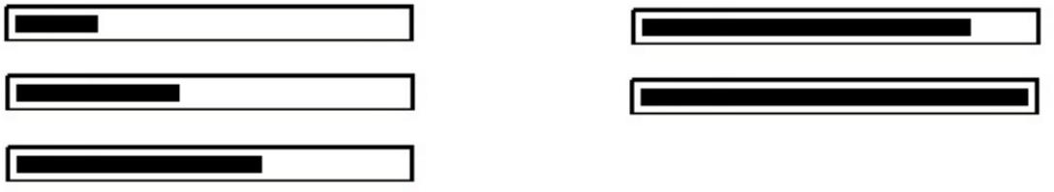

DP750/DP720 User Guide | P a g e | 40
Ringtones

Setting the Ringer Volume on the Handset

You can adjust the ringer volume for an incoming call to one of 6 levels (level 1 to 5 and off). Level 5 is the highest level. (The DP720 Handset is set to level 3 by default).

In order to configure the desired ringer volume, proceed as follows:

- Press Menu (left softkey or the selection key ) to bring up operation menu.

- Use arrow keys to reach Settings .

- Navigate to select Audio -> Volume

- Press the left and right arrow keys to change repeatedly and set the desired volume

- Press “Save” (left softkey ) to confirm the volume, and a message prompt will be displayed to confirm that the new volume has been successfully saved.
If you select OFF, the icon appears in the display and the handset will not ring for incoming calls.
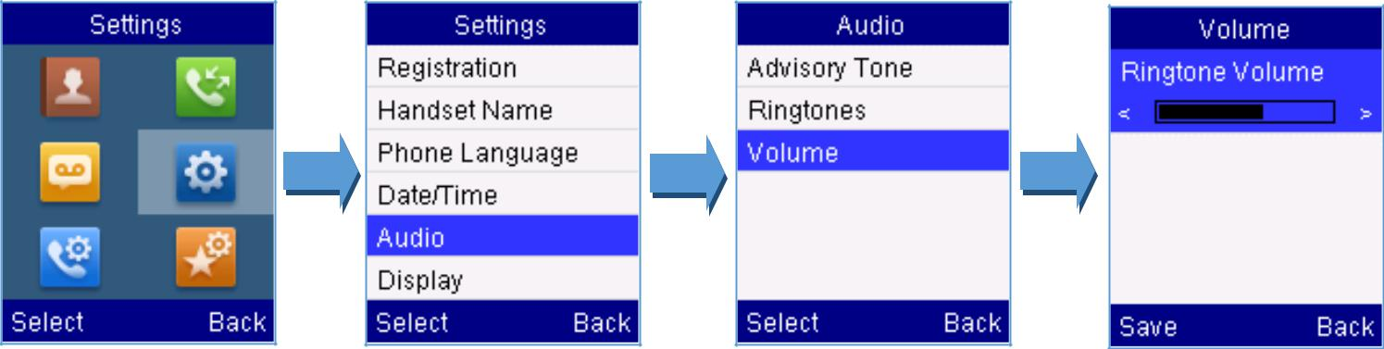

Figure 21: Ringer Volume

Setting the Ringer Melody on the Handset

You can change the ringer melody for an incoming call. The device has 8 different ringer melodies for you to choose from (1-8).

• The default setting for the ring tone for a call is melody 1. In order to configure the desired melody, proceed as follows:

- Press Menu (left softkey or the selection key ) to bring up operation menu.

- Use arrow keys to reach Settings .

- Navigate to select Audio -> Ringtones.

DP750/DP720 User Guide | P a g e | 41
- Press “Select” (left softkey ) to confirm the ringtones selected and a message prompt will be displayed to confirm that the new ringtones has been set successfully.
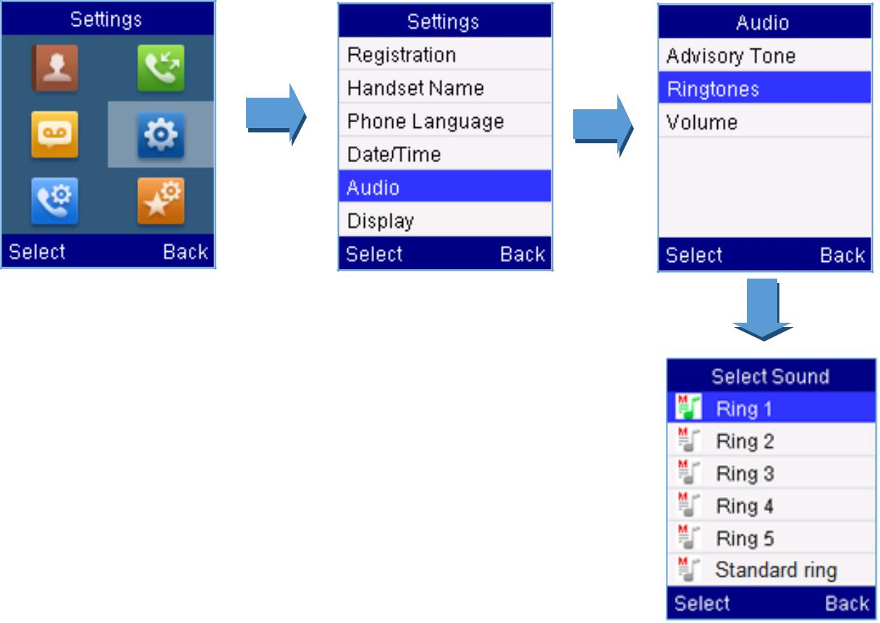

Figure 22: Calls Ringtones

Advisory Tones

Advisory tones are acoustic signals, which inform you of different actions and states on your handset. The

following advisory tones can be configured independently of each other:
- Keypad tone: it’s played when a user presses any key of the keypad.

- Confirmation: it’s played when a user saves settings or places the handset in the charger cradle.

- Low battery: it’s played if the capacity of the batteries is low or the handset requires charging.

To configure the advisory tones

- Press Menu (left softkey or the selection key ) to bring up operation menu.

- Use arrow keys to reach Settings .

- Navigate to select Audio -> Advisory tones, and choose which tone you want to change it.

- Press the left and right arrow keys to either enable or disable the desired tones.

DP750/DP720 User Guide | P a g e | 42
- Press “Save” (left softkey ) to confirm, and a message prompt will be displayed to confirm that the new settings has been successfully saved.
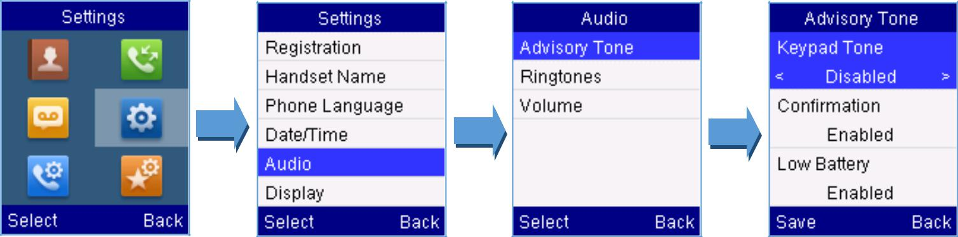

Figure 23: Advisory Tone

Date and Time

On the DP720 the Date and time are displayed on the idle screen and it obtains the date and time from the Simple Network Time Protocol (SNTP) server by default. If your handset cannot obtain the date and time from the SNTP server, you need to configure the date and time manually. You can configure the time format and date format respectively. The handset supports two time formats (12 Hour or 24 Hour) and three date formats (DD/MM/YYYY; MM/DD/YYYY; YYYY/MM/DD).

To configure date and time manually

- Press Menu (left softkey or the selection key ) to bring up operation menu.

- Use arrow keys to reach Settings .

- Navigate to Date and time. Edit the current values in the Date & Time fields (you can change the date / time format using the left key or right key and press “Set” (left softkey ).

- Press “Save” softkey to apply your changes.
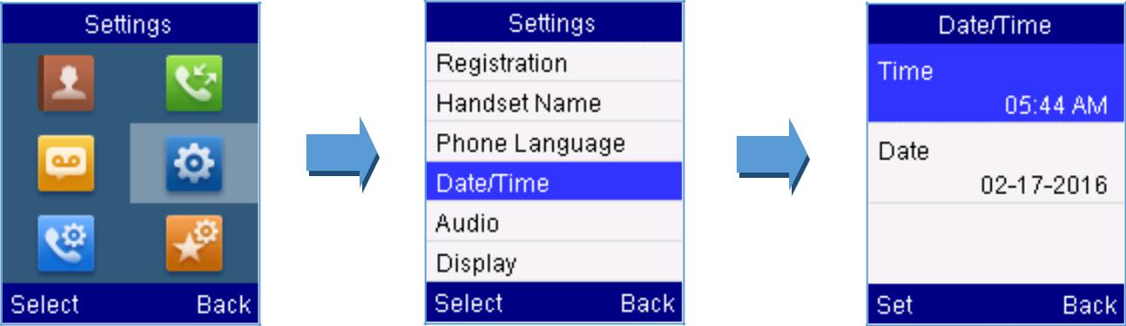

Figure 24: Date and Time Settings

DP750/DP720 User Guide | P a g e | 43
Outgoing Default Line

When a handset is configured with more than one line, users can change the default outgoing line on

DP720 handset using the keypad menu by following the steps bellow:
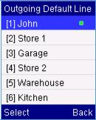
- Press Menu (left softkey or the selection key ) to bring up operation

menu and access Call settings > Outgoing Default Line .

- The LCD screen displays all outgoing lines currently assigned to the handset. Default outgoing line is highlighted with green button , select the desired line and press “Select” softkey.

Factory Functions

The factory functions include the following diagnostic options:

- LCD diagnostic

- LCD on / off

- Audio loopback

- Diagnostic mode

- Press Menu (left softkey or the selection key ) to bring up operation menu.

- Use arrow keys to reach Settings .

- Navigate to select Factory Functions and choose which diagnostic, you need to perform, and

then press “Select” (left softkey  ).

- Diagnostic mode

All LEDs will light up. All keys’ name will display in red on LCD screen before diagnosing. Press any key on the keypad to diagnose the key’s function. When done, the key’s name will display in blue on LCD with a prompt message (PASS). To exit press “Back” (right softkey  ).

- Audio loopback

Speak to the phone using speaker/handset/headset. If you can hear your voice, your audio is working fine. Press “Back” (left softkey ) to exit audio loopback mode.

- LCD ON / OFF

Selects this option to turn off LCD. Press any button to turn on LCD.

- LCD Diagnostic

Enters this option and press Left/Right arrow key to do LCD Diagnostic (you will notice that the color of the LCD will be changing). Press right softkey  to quite.

DP750/DP720 User Guide | P a g e | 44
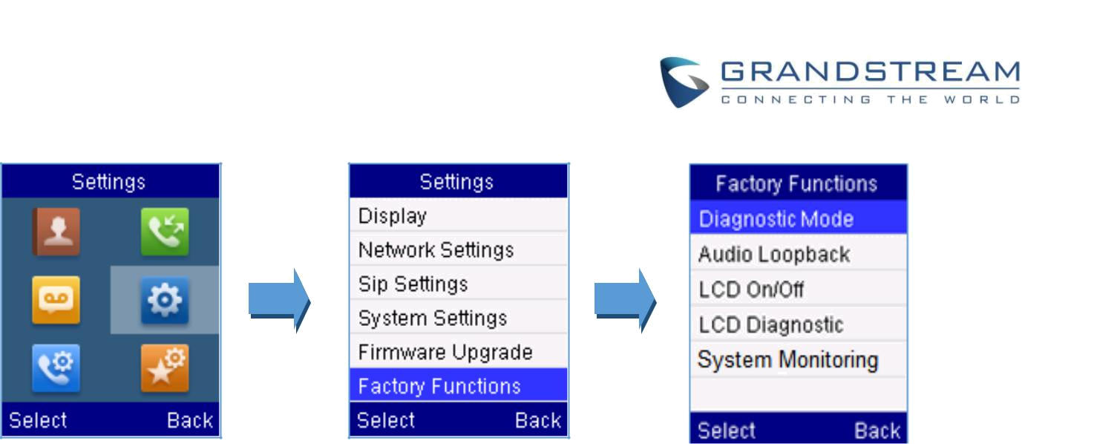

Figure 25: Factory Functions

Firmware Upgrade

The DP720 handset is able to detect if a new firmware is available when it is registered to a base station.
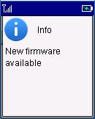

Figure 26: New Firmware Available Notification

To upgrade the firmware on your handset, follow the steps bellow:

- Press Menu (left softkey or the selection key ) to bring up operation menu.

- Use arrow keys to reach Settings .

- Navigate to select Firmware Upgrade and press the softkey “Select”.

- The LCD screen will display a prompt message to confirm the firmware downloading / upgrading press the right softkey “Back” to dismiss the upgrade process.
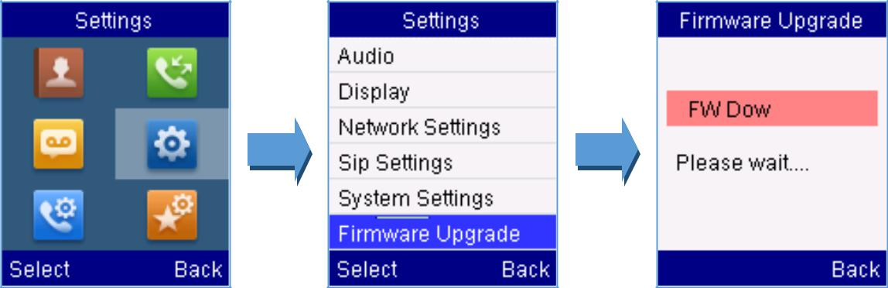

Figure 27: Firmware Upgrade

DP750/DP720 User Guide | P a g e | 45
Reboot DP750 Base Station

- Press Menu (left softkey or the selection key ) to bring up operation menu.

- Use arrow keys to reach Settings .

- Navigate to select Settings -> System Settings and choose Reboot Base.

4. Enter Base PIN code (by default the PIN code is: 0000 ).

- The LCD screen will displays a prompt message to confirm rebooting the base station, press “Yes” (left softkey ) to confirm or press “No” (right softkey  ) to cancel.
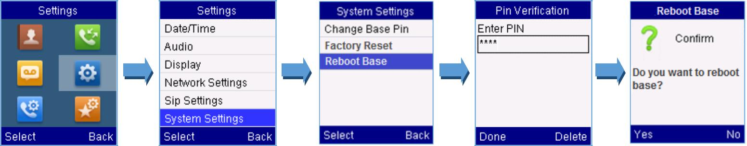

Figure 28: Rebooting the Base Station

Reset DP720 Handset

The users can reset the new settings made on the handset after performing factory reset. To reset your

handset to the default settings:

- Press Menu (left softkey or the selection key ) to bring up operation menu.

- Use arrow keys to reach Settings .

- Navigate to select Settings -> System Settings and choose Factory Reset.

- The LCD screen will displays a prompt message to confirm restoring factory settings, press “Yes” (left softkey ) to confirm and then the handset will reboot to apply the default settings or press “No” (right softkey ) to cancel.
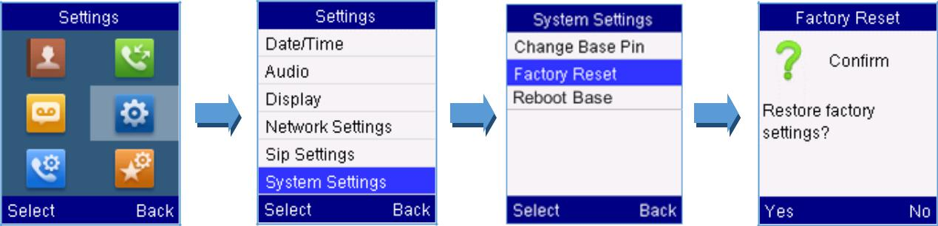

Figure 29: Resetting the Base Station

DP750/DP720 User Guide | P a g e | 46
CALL OPERATIONS

This chapter will guide you to place calls, transferring and holding the incoming calls.

Placing calls

To place calls, you can use the following mode:

- Earpiece mode: pressing the off-hook key to dial out.

- Speakerphone mode: pressing the speakerphone key to dial out.

- Headset mode: pressing the off-hook key to dial out using connected headset.

During the call, you can switch the call mode by pressing the corresponding keys or connecting a headset.

Make a Call using a Line

Making calls require the use of SIP lines. So you should first register the SIP account to the handset beforehand, after registering the sip lines, you can assign one or more outgoing lines for the handset. The handset can only use the assigned outgoing line(s) to place calls.

Please refer to the following methods in order to make calls using a line:

Method 1:
- Via default outgoing line:

  - Enter the desired number using the keypad.

  - Press Dial key  or Speaker key . The handset will use the default outgoing line to dial out.
  - To terminate the call, press Hang-Up key  .

Note : To change the default outgoing line, please refer to Outgoing Default line.

- Selecting the outgoing line:

  - Enter the desired number using the keypad.

  - Press the left softkey  “Call” .

  - Select the desired line to dial out.

  - To terminate the call, press Hang-Up key  .

Method 2:

- Press Dial key  or Speaker key to enter the pre- dialing screen.

- Enter the number to dial using the keypad.

DP750/DP720 User Guide | P a g e | 47
- Press Dial key  , # (Use # as dial key” must be configured in web configuration) or wait for 4 seconds and the call will be initiated automatically.
- To terminate the call, press Hang-Up key  .

During the call, you can switch the call mode by pressing the corresponding keys and cancel the dialing operation by pressing the on-hook key. During the call conversations, you can press the left and right navigation keys to adjust the volume. The call duration is displayed on the LCD screen while the call is in progress and call summary will be displayed once the call is terminated.

Notes: - To dial “+” please keep pressing “0” key for about 2 seconds.

- To dial from contacts list, choose a contact using navigation keys and press Dial key .

Dialing from Call history

Users may use their call history entries to initiate calls.

- Press Menu (left softkey  or the selection key ) to bring up operation menu.

- Use arrow keys to reach Call History Icon and then press “Select” (left softkey ).

- Select the desired entry, then press Dial key  to establish the call.

Note: In step 3, users can press “Options” softkey followed by “Edit Dial” option to initiate the call.

The call history list stores the last dialed phone numbers. When the memory of the redial number list is full, the handset will automatically erase the oldest dialed number when a new number is dialed

Dialing from Phonebook

Users may use their private or shared contacts to initiate calls.

- Press Contacts (right softkey  ) to access phonebook menu.

- Select Private or Shared phonebook.

- Select the contact to call.

- Press Dial Key to initiate the call.

Note: In step 3, users can press “Options” softkey followed by “Edit Dial” option to initiate the call.

DP750/DP720 User Guide | P a g e | 48
Answering Calls

When receiving an incoming call, you can answer the call using following steps:

- Earpiece mode:

Press Dial Key to pick up the call, or “Accept” softkey (left softkey ).

- Speakerphone mode:

Press Speaker Key to pick up the call.

- Headset mode:

Press Dial Key to pick up the call, or “Accept” softkey (left softkey  ) using a connected

headset.

Note:

- To answer an incoming call during an established call, press Dial Key , or the Speaker Key , or the “Answer” softkey. The incoming call is answered, and the original call is placed on hold.

- You can switch off the ringer temporarily by pressing Silent softkey.

Ending Calls

To terminate the calls, press Hang-Up key .

Rejecting Calls

To reject an incoming calls, press Hang-Up key or “Reject” softkey (right softkey  )

Auto Answer

To simply answer the incoming calls by picking up the handset from the charger cradle without having to press the off-hook key.

The auto answer feature works only if the handset is placed in the charger cradle.

To activate / deactivate the auto answer feature

- Press Menu (left softkey or the selection key ) to bring up operation menu.

- Use arrow keys to reach Call settings , and navigate to Auto Answer using the Up / down keys arrow.
- Press the left softkey “Save” after Enabling / Disabling the auto answer option.

DP750/DP720 User Guide | P a g e | 49
Direct IP Call

Direct IP calling allows two parties, that is, a handset and another VoIP device, to talk to each other in an

ad hoc fashion without a SIP proxy.

Elements necessary to complete a Direct IP Call:

- Both DP720 and other VoIP Device, have public IP addresses, or

- Both DP720 and other VoIP Device are on the same LAN using private IP addresses, or

- Both DP720 and other VoIP Device can be connected through a router using public or private IP addresses (with necessary port forwarding or DMZ).

Users can perform IP calls using Star code following the below steps:

- Pick up the handset and press Dial key .

- Dial *47 followed by the target IP Address.

Note: You can enter directly *47 + target IP address, and then press the dial key to initiate the call. Examples of direct IP calls

- If the target IP address is 192.168.0.160, the dialing convention is *47 then 192*168*0*160, followed by pressing the “#” key if it is configured as a send key or wait 4 seconds. In this case, the default destination port 5060 is used if no port is specified.

- If the target IP address/port is 192.168.1.20:5062, then the dialing convention would be:

*47 or Voice Prompt with option 47, then 192*168*0*160*5062 followed by pressing the “#” key if it is configured as a send key or wait for 4 seconds.

Note: To use direct IP call, Use Random Port setting should be set to NO.

Call Hold/Resume

During an established call, you can put the call on hold and resume following below steps:

- Press the left softkey  to access the call Options and then navigate to Hold.

- Press “Select”, left softkey to put the call on hold.

- To resume the call, access the options menu again and navigate to Resume, then press Select.

If you press during the call, the first call will be on hold, and you can establish a new call; to resume

the initial call, press .

Call Waiting

This feature will notify you of a new incoming call during an established call, and display the incoming call information visually on the LCD screen and a call waiting tone will be heard. If this feature is disabled, the new incoming call will be automatically rejected.

DP750/DP720 User Guide | P a g e | 50
To activate the call waiting feature, follow the next steps:

- Press Menu (left softkey  or the selection key ) to bring up operation menu.

- Access to Call settings and then to Call waiting sub-menu.

- Select the account for which you want to enable the Call waiting feature, and then press left softkey “Select” .

- Choose between Enabled and Disabled options and press the softkey “Save”, a prompt message will be displayed to confirm that the call waiting is enabled / disabled.

- During an established call, press (dial key) to put first call on hold and answers second incoming call. If no second incoming call, pressing  will give the ability to initiate another call while first one is on hold.

Note: You can switch between active/on-hold calls by pressing Options > Swap.

Do Not Disturb

You can activate or deactivate the DND mode for your accounts registered on the handset under the call settings. If DND mode is activated for a specific line, all incoming calls will receive busy treatment depending on your configuration (forward to voice mail, busy tone…)

To enable or disable the DND mode, follow the next steps

- Press Menu (left softkey or the selection key ) to bring up operation menu.

- Access Call settings and then to Do Not Disturb sub-menu.

- Select the account on which you want to enable / disable the DND mode and then press “Select”

- Choose between Enabled and Disabled options and press softkey “Save” to accept the changes, a prompt message will be displayed to confirm that the DND is enabled / disabled.

You can check the line status if the DND mode is enabled on the base station.

Call forward

The call forward feature will allow you to forward all the incoming calls to the desired number. Three possible call forward types are available on the DP720.

- Forward all: All the incoming calls are immediately forwarded.

- Busy Forward: Incoming calls are immediately forwarded if the line is busy.

DP750/DP720 User Guide | P a g e | 51
- No Answer Forward: Incoming calls are forwarded if not answered after a period of time.

To enable the call forward, please refer to the following steps:

- Press Menu (left softkey or the selection key ) to bring up operation menu.

- Access to Call settings and then to Call Forward sub-menu.

- Select the account on which you want to enable/disable the call forward feature and press

“Select”.

- Select the type of call forwarding and enter the number to forward the calls, and then press “Save” (left softkey ) to apply the settings, a prompt message will be displayed to confirm that the new settings have been saved successfully.

Call transfer

The DP720 supports the call transfer feature, you can transfer a call to another party using one of the following ways:

- Blind transfer: Transfer a call directly to another party without consulting

- Attended transfer: Transfer a call with prior consulting.

Blind Transfer

- Press the “Options” softkey (Left softkey ) during a call, and then select Transfer.

- The initial call will be on hold, enter the number or select the handset you want to transfer the call to.

- Press Dial key . The call is connected to the number or the handset you specified, and the LCD screen prompts Call Transferred.

Attended Transfer

- Press Left softkey “Options” during a call, and then select New call.

- Choose the line and enter the number you want to transfer the call to, then press Dial key .

- Once the second call is established, press left softkey “Option” and select Transfer.

Speed Dial

Speed dial allows users to perform single-digit dialing to predefined numbers. This feature is particularly useful to speed up dialing the numbers that frequently used or hard to remember. A maximum of 8 speed

DP750/DP720 User Guide | P a g e | 52
dial numbers is allowed. For example, the digit key 2 is configured as a speed dial key and assigned the number 2000, the phone will dial out the number 2000 directly when you long press digit key 2.

To assign the frequently used numbers from your shared contacts as speed dial keys:

- Press Menu (left softkey or the selection key ) to bring up operation menu.

- Access to Call settings and then to Speed Dial sub-menu.

- Choose the digit keys (2-9) and press Assign to specify the number (from the shared directory) to be as speed dial.

You can press Change or Delete softkeys to modify/delete a speed dial key

3-Way Conference

The DP720 supports creating a local conference with other parties (including handset starting the conference).

To start a 3 Way conference, follow below steps:

- Press the Dial key to place a call to the first party.

- Press left softkey “Options” , then select Conference

- Enter the number of the second party you want to add to the conference and press Dial Key .

To drop the conference call, press  or “End” softkey.

Note: Conference can be bridged before third party answers.

Voice Mail

The voice mail feature ensures that you will never miss any important messages. It permits either to leave voice mails to someone else or receive and listen to voice mails via the handset

Set Voice mail feature code

- Press Menu (left softkey or the selection key ) to bring up operation menu.

- Access to Voice Mail and then select Set Voice Mail sub menu.

- Select the account and enter the voice mail code feature, then press “Save” softkey.

Play voice mail messages

1. Press “Menu” (left softkey or the selection key ) to bring up operation menu.

DP750/DP720 User Guide | P a g e | 53
- Access to Voice Mail and then select Play Message sub menu.

- Select the account to retrieve your voice messages saved on your voice mail.

Note: Users can access directly voicemail menu to play messages, by clicking on “View” (left softkey )

when the notification of a new voicemail pops up on the DP720’s LCD screen.

Call Features

The DP750/DP720 supports traditional and advanced telephony features including caller ID, caller ID with caller Name, call forward and etc.

Table 10: Call Features

 |  |  |  |  | Block Caller ID (for all subsequent calls)
 | *30 |  |  |  | • | Off hook the phone;
 |  |  |  |  | • | Dial *30.
 |  |  |  |  | Send Caller ID (for all subsequent calls)
 | *31 |  |  |  | • | Off hook the phone;
 |  |  |  |  | • | Dial *31.
 |  |  |  |  | Disable Call Waiting
 | *50 |  |  |  | • | Off hook the phone;
 |  |  |  |  | • | Dial *50.
 |  |  |  |  | Enable Call Waiting
 | *51 |  |  |  | • | Off hook the phone;
 |  |  |  |  | • | Dial *51.
 |  |  |  |  | Call with Caller ID Blocked (per call)
 | *67 |  |  |  | • | Off hook the phone;
 |  |  |  |  | • Dial *67 and then enter the number to dial out.
 |  |  |  |  | Call with Caller ID Enabled (per call)
 | *82 |  |  |  | • | Off hook the phone;
 |  |  |  |  | • Dial *82 and then enter the number to dial out.
 |  |  |  |  | Call with Call Waiting Disable (per Call)
 | *70 |  |  |  | • | Off hook the phone;
 |  |  |  |  | • Dial *70 and then enter the number to dial out.
 | *71 |  |  |  | Call with Call Waiting Enabled (per Call)

DP750/DP720 User Guide | P a g e | 54

- Off hook the phone;

- Dial *71 and then enter the number to dial out.

Unconditional Call Forward. To set up unconditional call forward:

- Off hook the phone;
*72
• Dial *72 and then enter the number to forward the call;

• Press OK softkey or SEND key.

Cancel Unconditional Call Forward. To cancel the unconditional call forward:

- Off hook the phone;
*73
• Dial *73;

• Hang up the call.

Busy Call Forward. To set up busy call forward:

- Off hook the phone;
*90
• Dial *90 and then enter the number to forward the call;

• Press OK softkey or SEND key.

Cancel Busy Call Forward. To cancel the busy call forward:

- Off hook the phone;
*91
• Dial *91;

• Hang up the call.

Delayed Call Forward. To set up delayed call forward:

- Off hook the phone;
*92
• Dial *92 and then enter the number to forward the call;

• Press OK softkey or SEND key.

Cancel Delayed Call Forward. To cancel the delayed call forward:

- Off hook the phone;
*93
• Dial *93;

• Hang up the call.

DP750/DP720 User Guide | P a g e | 55
RESTORE FACTORY DEFAULT SETTINGS


Warning:

Restoring the factory default settings will delete all configuration information on the phone. Please backup or print all the settings before you restore to the factory default settings. Grandstream is not responsible for restoring lost parameters and cannot connect your device to your VoIP service provider.

Please follow the instructions below to reset the phone:

- Press MENU button to bring up the keypad configuration menu;

- Select Settings and enter;

- Select System Settings > Factory Reset;

- A warning window will pop out to make sure a reset is requested and confirmed;

- Press Yes softkey to confirm and the phone will reboot. To cancel the Reset, press No softkey instead.

DP750/DP720 User Guide | P a g e | 56
EXPERIENCING DP750/DP720

Please visit our website: http://www.grandstream.com to receive the most up- to-date updates on firmware releases, additional features, FAQs, documentation and news on new products.

We encourage you to browse our product related documentation, FAQs and User and Developer Forum for answers to your general questions. If you have purchased our products through a Grandstream Certified Partner or Reseller, please contact them directly for immediate support.

Our technical support staff is trained and ready to answer all of your questions. Contact a technical support member or submit a trouble ticket online to receive in-depth support.

Thank you again for purchasing the Grandstream DP720 / DP750, it will be sure to bring convenience and color to both your business and personal life.

DP750/DP720 User Guide | P a g e | 57

