

Grandstream Networks, Inc.

Guia Básico de Configuração UCM6510

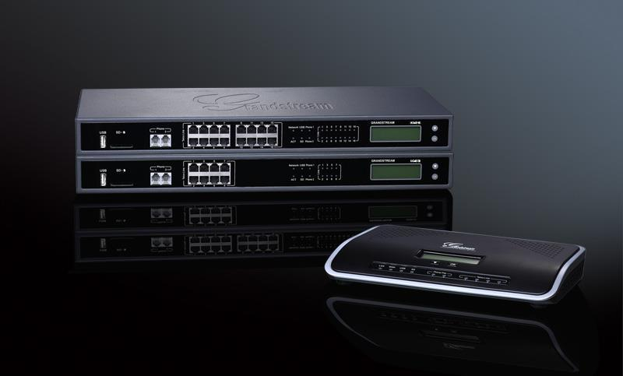



**Index**

**Sumário**

**VISÃO GERAL****4**

**SETUP ENVIRONMENT****5**

**INSTALAÇÃO RÁPIDA****6**

CONECTE UCM6510 6

ACESSE INTERFACE WEB DO UCM6510 6

**CRIANDO UMA EXTENSÃO DE USUÁRIO****8**

CONFIGURE O ALCANCE DA EXTENSÃO 8

CRIAÇÃO DO USUÁRIO E DO LOTE 9

*PASSOS PARA ADICIONAR UMA EXTENSÃO ÚNICA**9*

*PASSOS PARA ADICIONAR LOTES DE EXTENSÃO**10*

**PROVISIONANDO & CONFIGURAÇÃO ZERO** **13**

BUSCA AUTOMÁTICA 13

MOSTRANDO EXTENSÕES 14

**CONFERENCE BRIDGE****16**

COMO CONFIGURAR UMA CONFERENCE BRIDGE 16

**IVR****19**

CONFIGURE UMA IVR 19

CRIAR NOVA IVR 19

**TRUNKS****21**

ANALOG TRUNKS 21

*SET UP ANALOG TRUNK**21*

VOIP TRUNKS 22

*SET UP VOIP TRUNK**23*

DIGITAL TRUNKS 25

**CALL ROUTES****26**

OUTBOUND ROUTES 26

*SET UP OUTBOUND ROUTE**26*

INBOUND ROUTES 28

*SET UP INBOUND ROUTE**28*

UCM6510 Basic Configuration Guide Page 1 of 29



**Table of Figures**

Figure 1: Typical UCM6510 Connection Scenario 5

Figure 2: Connecting UCM6510 6

Figure 3: UCM6510 Web UI Login Screen 7

Figure 4: Create User Extension - Extension Range 8

Figure 5: PBX -> Basic/Call Routes -> Extensions 9

Figure 6: Create New Extension 9

Figure 7: Create New SIP Extension 10

Figure 8: Create User Extension - Created Single User 10

Figure 9: Batch Add SIP Extension 11

Figure 10: Create User Extension - Batch Add User 11

Figure 11: Create User Extension - Prompt 12

Figure 12: Create User Extension - Single and Batch Add Extensions Created 12

Figure 13: Provisioning with Zero Config - Auto Discovery 14

Figure 14: Provisioning with Zero Config - Extension Assignment 14

Figure 15: Provisioning with Zero Config - Manually Assigned Extension 15

Figure 16: Provisioning with Zero Config - Extension Status 15

Figure 17: Conference Bridge - Create New Conference Room 17

Figure 18: Conference Bridge - Create New Conference Room 17

Figure 19: Conference Bridge - Conference in Progress 18

Figure 20: IVR - Manage IVR 19

Figure 21: IVR - Create New IVR 20

Figure 22: IVR - Key Pressing Events 20

Figure 23: Analog Trunks - Create New Analog Trunk 22

Figure 24: VoIP Trunks - Create New Register SIP Trunk 24

Figure 25: VoIP Trunks - Edit VoIP Trunk 24

Figure 26: Status - Trunks 25

Figure 27: Routes – Create Outbound Route 27

Figure 28: Routes - Create Inbound Route 29

This document is subject to change without notice. The latest electronic version of this document is available for download here:

<http://www.grandstream.com/support>

UCM6510 Basic Configuration Guide Page 2 of 29



Reproduction or transmittal of the entire or any part, in any form or by any means, electronic or print, for any purpose without the express written permission of Grandstream Networks, Inc. is not permitted.

UCM6510 Basic Configuration Guide Page 3 of 29



**VISÃO GERAL**

Este documento irá fornecer instruções sobre como configurar um UCM6510 de um estado fora da caixa para um estado totalmente funcional. Isso inclui considerações de projeto, criação de extensões de usuários, provisionamento de pontos de extremidade com Zero-Config, conferência, configuração de atendimento automático, troncos analógicos / VoIP, roteamento de chamadas de entrada / saída e configuração de correio de voz / fax para email.

Para obter informações detalhadas sobre os parâmetros encontrados neste guia, consulte o [UCM6510 series User Manual.](http://www.grandstream.com/products/ucm_series/ucm65xx/documents/ucm6510_usermanual.pdf)

UCM6510 Basic Configuration Guide Page 4 of 29



**MEIOS DE CONFIGURAÇÃO**

Neste guia de configuração, usaremos o UCM6510 conectado em um ambiente como mostrado na figura abaixo. Ele mostra uma configuração típica onde você tem a porta WAN UCM6510 conectada à Internet eo lado LAN do UCM6510 fornecendo DHCP para telefones GXP, bem como PCs.

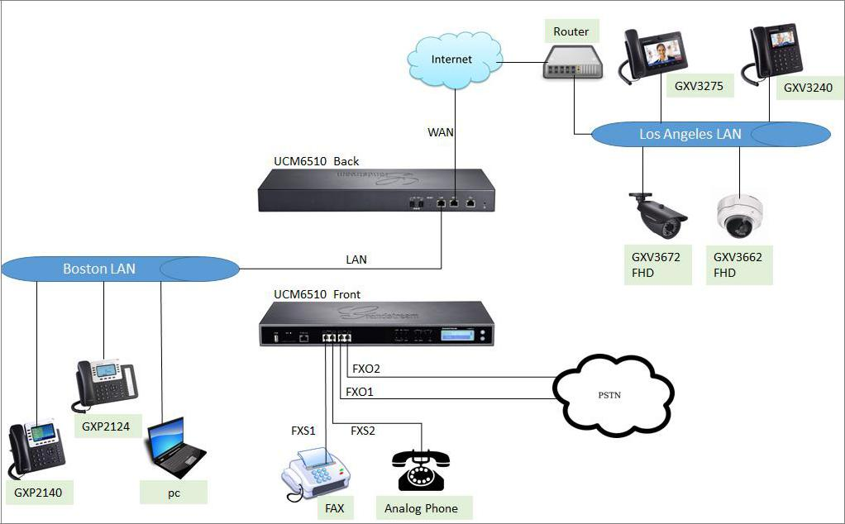

**Figure 1: Typical UCM6510 Connection Scenario**

Para conexão T1 / E1 / J1, consulte a documentação aqui: [http://www.grandstream.com/products/ucm_series/ucm65xx/documents/how_to_configure_t1_on_ucm65](http://www.grandstream.com/products/ucm_series/ucm65xx/documents/how_to_configure_t1_on_ucm6510.pdf) [10.pdf](http://www.grandstream.com/products/ucm_series/ucm65xx/documents/how_to_configure_t1_on_ucm6510.pdf)

UCM6510 Basic Configuration Guide Page 5 of 29



**INSTALAÇÃO RÁPIDA**

**CONECTE UCM6510**

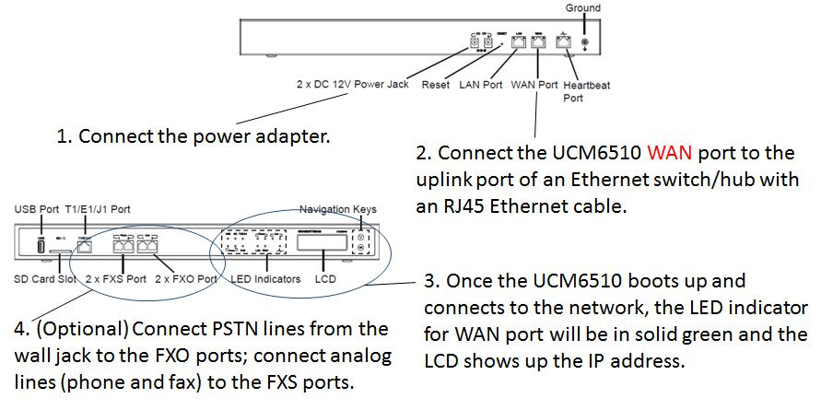

**Figure 2: Connecting UCM6510**

O UCM6510 irá então obter conexão de rede uplink após a instalação acima. Os usuários podem então conectar a porta LAN a um switch / hub que pode ter mais telefones IP e PCs para se conectar, usando UCM6510 como um roteador para a rede LAN.

**ACCESSANDO A INTERFACE WEB DO UCM6510**

O acesso à interface web UCM6510 permite que os usuários gerenciem os usuários e as configurações do sistema localmente e remotamente. Se o computador estiver conectado ao mesmo switch / roteador que a porta WAN UCM6510 está conectada, os usuários podem navegar até o endereço IP exibido no LCD UCM6510. Este endereço é o IP WAN. Se o computador estiver conectado ao lado LAN do UCM6510, os usuários procurariam o IP padrão do UCM6510, que é 192.168.2.1. Se for bem-sucedido, a página de login UCM6510 será exibida como mostrado abaixo.

UCM6510 Basic Configuration Guide Page 6 of 29

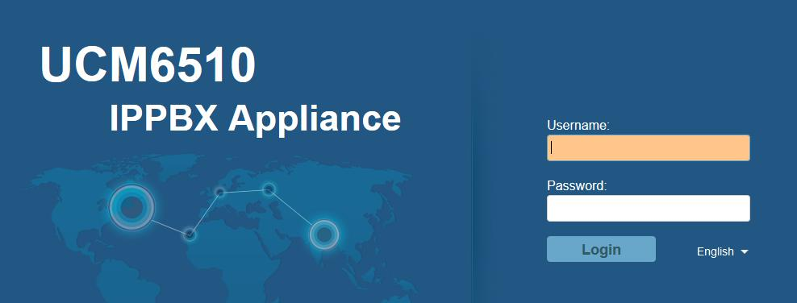

**Figure 3: UCM6510 Web UI Login Screen**

UCM6510 Basic Configuration Guide Page 7 of 29



**CREATE USER EXTENSION**

**CONFIGURE O ALCANCE DA EXTENSÃO**

A primeira parte da configuração do UCM6510 deve ser sobre o planejamento da extensão. Aqui estão algumas perguntas sobre como configurar intervalos de extensão:

* Quantos usuários estão no escritório?
* Haverá departamentos dentro do escritório?
* Este escritório está interligado com outro escritório?

Uma vez que há uma imagem clara de quantos usuários serão em cada local, como os departamentos serão segmentados e qual é o crescimento esperado da empresa, um usuário pode então configurar o intervalo de extensão. Navegar para a Web UI->**PBX**->**Internal Options**->**General**.

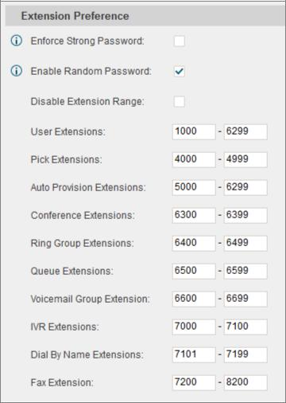

**Figure 4: Create User Extension - Extension Range**

UCM6510 Basic Configuration Guide Page 8 of 29



Na figura acima, o intervalo de extensão do usuário é definido com uma extensão inicial de 1000 e terminando em 6299. Isso permite até 5300 extensões para atribuir aos usuários. Criamos também uma extensão de conferência de 6300 a 6399, que oferece 99 pontes de conferência. Os usuários podem configurar qualquer intervalo de extensão conforme desejarem. Aqui nós o configuramos para usar extensões de 4 dígitos.

Clique em "Salvar" na parte inferior. Então lembre-se de clicar em "Aplicar alterações" no topo para que nosso intervalo de extensão estará pronto para os próximos passos.

**CRIAÇÃO DE LOTE E USUÁRIO**

Portanto, agora que há intervalo de extensão configurado, podemos começar a criar usuários para se preparar para o processo de provisionamento. Existem dois métodos para criar um usuário. Um método seria a criação de um único usuário. O outro método seria a criação de um lote de usuários. Neste tutorial, apresentamos como criar uma extensão SIP como exemplo.

**STEPS ON ADDING SINGLE EXTENSION**

1. Navegue por **PBX**->**Basic/Call Routes**->**Extensions**. Para a primeira configuração, os usuários verão “No Extensions defined”.

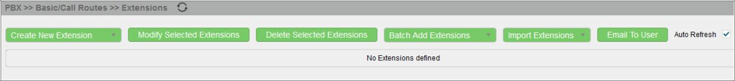

**Figure 5: PBX -> Basic/Call Routes -> Extensions**

2. Clique em “Create New Extension” e selecione “Create New SIP Extension” Da lista suspensa.

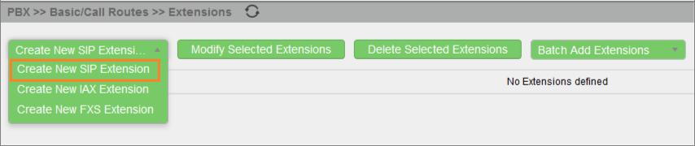

**Figure 6: Create New Extension**

1. Em “Create New SIP Extension” , Os usuários podem entrar em algumas opções, mas eles não são necessários para este tutorial. Clique “Save” Na parte inferior da página.

UCM6510 Basic Configuration Guide Page 9 of 29

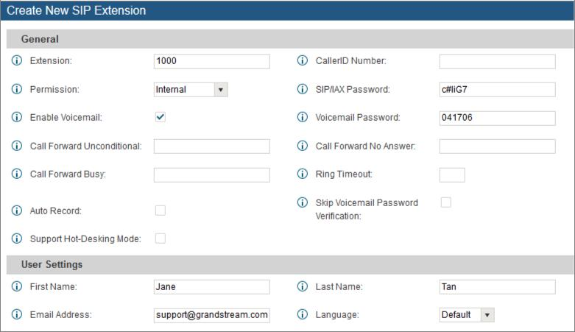

**Figure 7: Create New SIP Extension**

1. Depois de clicar em “Save” A página Extensões será exibida com a única extensão SIP que acabou de ser criada. Aqui o usuário tem a habilidade de editar as extensões clicando em  à direita.



**Figure 8: Create User Extension - Created Single User**

**STEPS ON ADDING BATCH OF EXTENSIONS**

1. Navegue em **PBX**->**Basic/Call Routes**->**Extensions**
2. Clique em “Batch Add Extensions” e depois selecione “Batch Add SIP Extension” no drop down.

UCM6510 Basic Configuration Guide Page 10 of 29

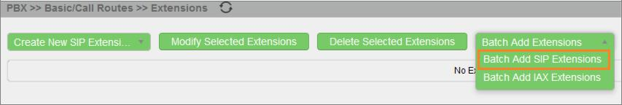

**Figure 9: Batch Add SIP Extension**

1. Em “Batch Add Extensions”, O usuário pode especificar o “Starting Extension” e o número de extensões a gerar, definindo em “Create Number”. Neste tutorial teremos uma extensão inicial de 1001 e teremos a UCM6510 Gerando 5 extensões com uma senha gerada aleatoriamente. This would create extensions 1001, 1002, 1003, 1004 and 1005.

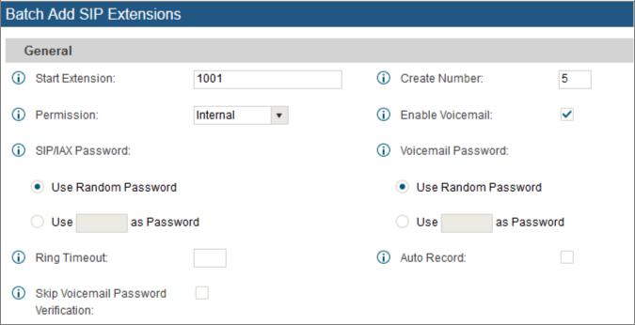

**Figure 10: Create User Extension - Batch Add User**

1. Click “Create Users” at the bottom to have the UCM6510 generate the extensions
2. Next, a prompt will appear asking “Are you sure you want to create users: 1001, 1002, 1003, 1004 1005”. Click on “OK”.

UCM6510 Basic Configuration Guide Page 11 of 29

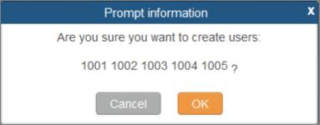

**Figure 11: Create User Extension - Prompt**

At this point the Extensions page should look similar to this:

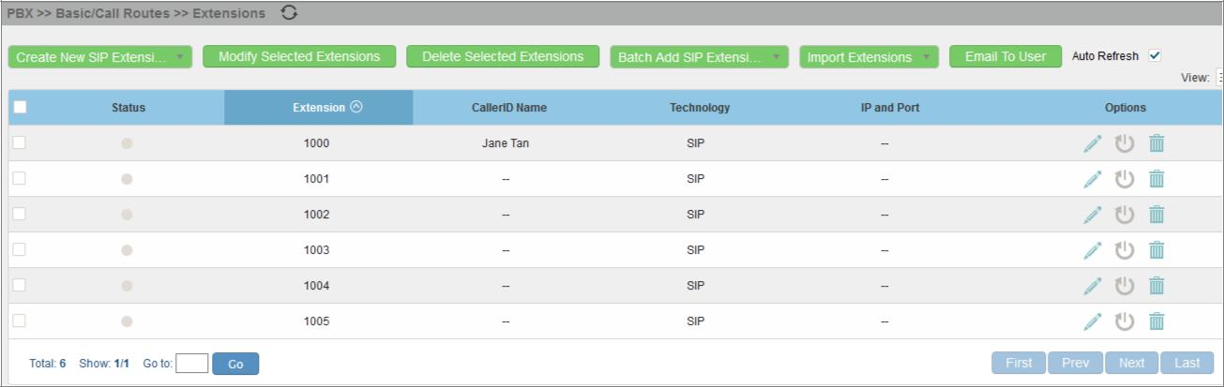

**Figure 12: Create User Extension - Single and Batch Add Extensions Created**

UCM6510 Basic Configuration Guide Page 12 of 29



**PROVISIONING & ZERO CONFIG**

Grandstream SIP Devices can be configured via Web interface as well as via configuration file through TFTP/HTTP/HTTPS download. All Grandstream SIP devices support a proprietary binary format configuration file and XML format configuration file. The UCM6510 provides a Plug and Play mechanism to auto-provision the Grandstream SIP devices in a zero configuration manner by generating XML config file and having the phone to download it. This allows users to finish the installation with ease and start using the SIP devices in a managed way.

To provision a phone, three steps are involved, i.e., discovery, assignment and provisioning. The UCM6510 creates XML config file to the detected/assigned Grandstream device and accomplishes the following configurations on the device after the provisioning:

* A UCM6510 extension will be assigned and registered on the phone.
* SIP-related network settings such as "NAT traversal" and "Use Random Port" are configured on the phone.
* Call settings such as "Dial Plan" and "Auto Answer".
* LDAP client configurations will be set up automatically on the phone to use the default LDAP directory generated in the UCM6510 LDAP server.

This section explains how zero config works on the UCM6510. The settings for this feature can be accessed via Web GUI->**PBX**->**Basic/Call Routes**->**Zero Config**.

**AUTO DISCOVERING**

When referring back to our typical scenario in the beginning of this tutorial, we know that there is a GXP2124 connected to the LAN side of the UCM6510. The UCM6510 LAN interface has DHCP enabled and has assigned the GXP2124 with an IP address. By default the IP assigned would be within the 192.168.2.X range. When the UCM6510 offers an IP address to the phone it also offers DHCP Option 66, which provides the phone with a config server path that points to the UCM6510. All of Grandstream VoIP devices have Option 66 turned on by default and this is how the GXP2124 was discovered by the UCM6510.

Upon being discovered, the GXP2124 will provide details about its MAC, IP Address, Version (Firmware), Vendor, Model, Connection Status and Create Config.

By navigating to **PBX**->**Basic/Call Routes**->**Zero Config**, a user will be able to see the discovered device(s).

UCM6510 Basic Configuration Guide Page 13 of 29

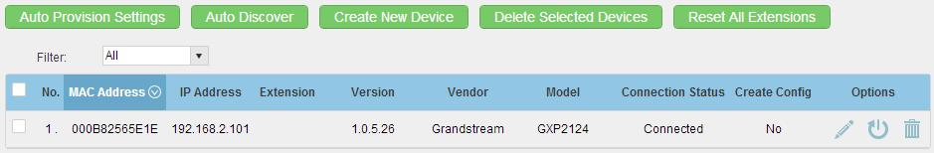

**Figure 13: Provisioning with Zero Config - Auto Discovery**

**EXTENSION ASSIGNMENT**

In the Auto Provision settings, users have the option to enable “Automatically Assign Extension”. If enabled, an extension will be created and assigned to the new device detected. This is a great feature if specific extension assignment isn’t required, but for our setup we’ll work on manually assigning an extension to a discovered device.

Navigate to **PBX**->**Basic/Call Routes**->**Zero Config** and click on  for the discovered device.

The next screen provides details of the device and also allows a user to assign an extension. Since the GXP2124 is a 4 line phone, the UCM6510 gives us the option to assign 4 extensions to the phone.

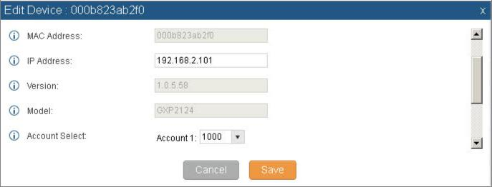

**Figure 14: Provisioning with Zero Config - Extension Assignment**

Click on the Account 1 and select the desired extension, then click “Save”. Now the Zero Config page displays the device with an extension assigned to it on Account 1.

UCM6510 Basic Configuration Guide Page 14 of 29



**Figure 15: Provisioning with Zero Config - Manually Assigned Extension**

After assigning an extension, the phone must be rebooted in order to pick up the configuration file from the UCM6510. During this process, the phone will boot up, request for config file, download the config file, then reboot once more in order to apply the changes.

After the phone is completely booted, navigate to **PBX**->**Basic/Call Routes**->**Extensions** page to see the extension status. The SIP status will show a green circle for a successful registration.



**Figure 16: Provisioning with Zero Config - Extension Status**

UCM6510 Basic Configuration Guide Page 15 of 29



**CONFERENCE BRIDGE**

The UCM6510 supports up to 8 conference bridges allowing up to 64 simultaneous PSTN or IP participants.

The conference bridge configurations can be accessed under Web GUI->**PBX**->**Call** **Features**->**Conference**. In this page, users could create, edit, view, invite, manage the participants anddelete conference bridges. The conference bridge status and conference call recordings (if recording is enabled) will be displayed in this web page as well.

**HOW TO SET UP A CONFERENCE BRIDGE**

1. Click on “Create New Conference Room”
2. On the “Create New Conference Room” dialog, the Extension is automatically populated since the extension range is in effect. Users can assign another number that is within the Conference Extension range
3. Next, uncheck the option “Public Mode”. This will make the password options available. Enter a numeric password for an admin as well as the regular user password. In this example, the user enters 511511 as the user password and 510510 as the admin password.

UCM6510 Basic Configuration Guide Page 16 of 29

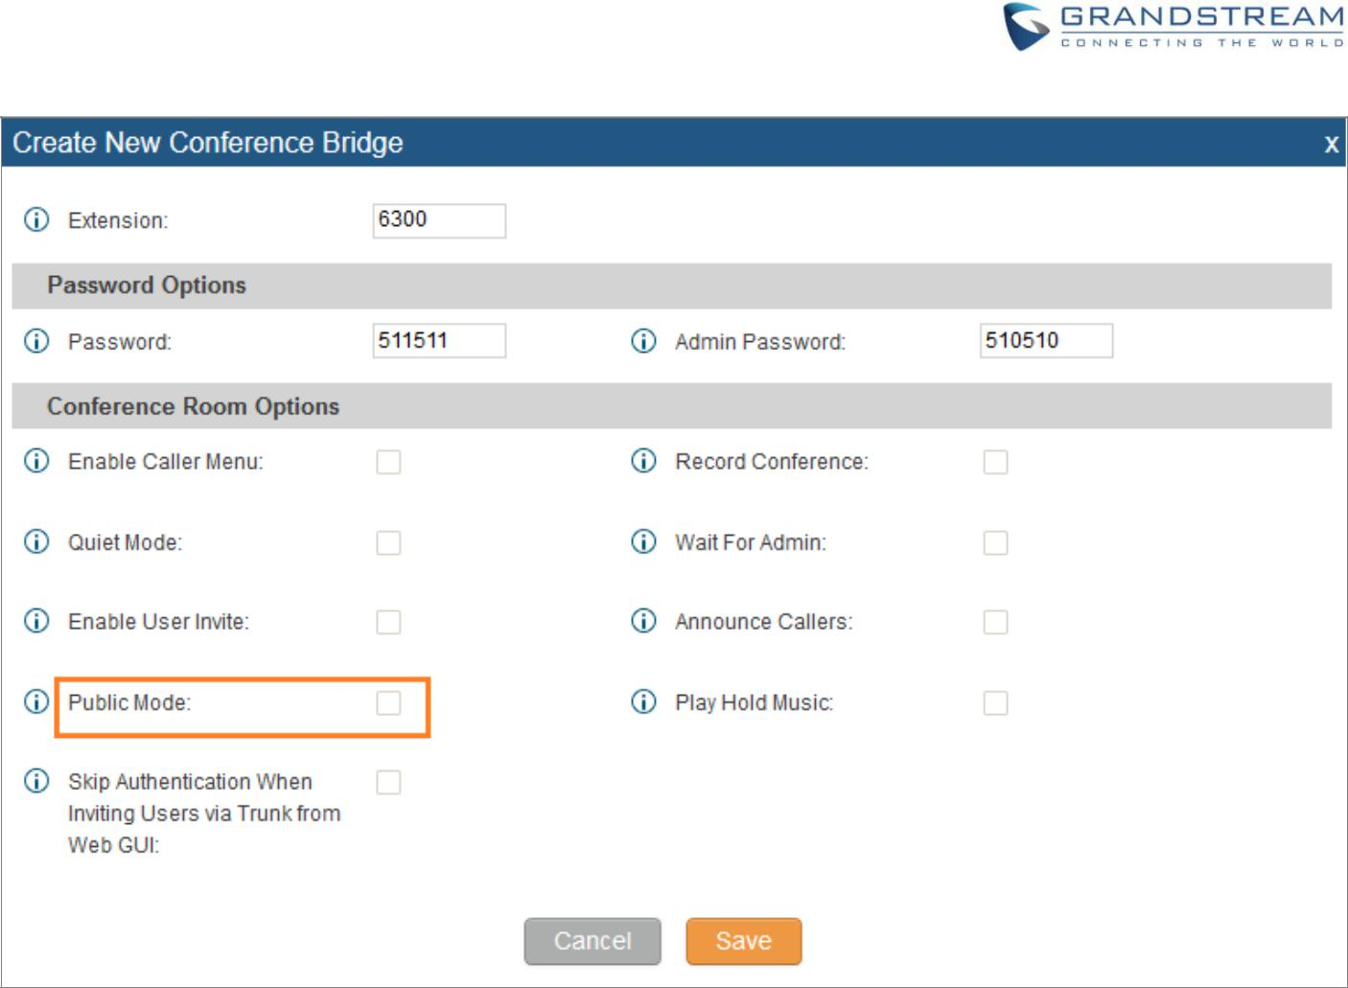

**Figure 17: Conference Bridge - Create New Conference Room**

4. Click “Save” at the bottom then “Apply Changes” at the top.

We should now have a conference room created and the status page will display the following:



**Figure 18: Conference Bridge - Create New Conference Room**

With the phone that was registered to the UCM6510, dial the conference room extension. For this example we will dial 6300. The user will hear a prompt for the conference password. Depending on the user, the regular password or admin password can be entered.

During a conference call, the admin can login to the UCM6510 web GUI and view the conference room status. This provides the admin with details on which conference room is active, who the participants are and the conference call current duration.

UCM6510 Basic Configuration Guide Page 17 of 29



Besides status information, the admin has a several conference management tools. By clicking the

button, the admin can invite other users to the conference. Clicking  will kick the selected user from the

conference. When clicking  or  button the admin will mute/unmute the specific user.

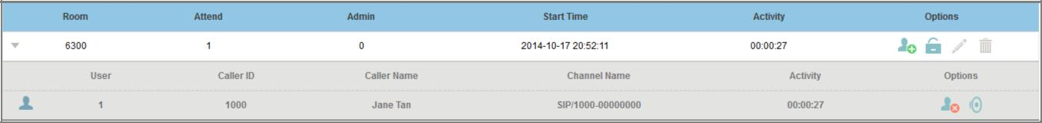

**Figure 19: Conference Bridge - Conference in Progress**

UCM6510 Basic Configuration Guide Page 18 of 29



**IVR**

**CONFIGURE IVR**

IVR configurations can be accessed under the UCM6510 Web GUI->**PBX**->**Call Features**->**IVR**. Users could create, edit, view and delete an IVR.

* Click on "Create New IVR" to add a new IVR.
* Click on  to edit the IVR configuration.
* Click on  to delete the IVR.

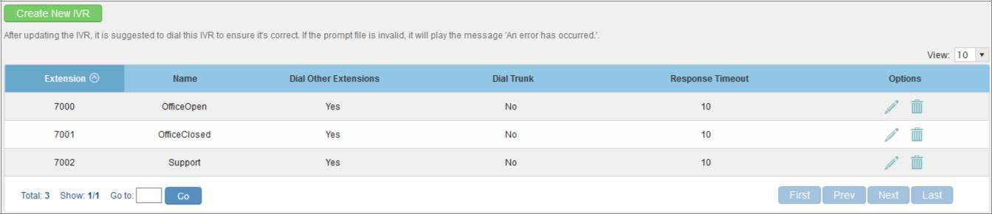

**Figure 20: IVR - Manage IVR**

**CREATE NEW IVR**

1. Click on “Create New IVR”
2. Enter a Name for the IVR. This is used for referencing purposes. In this example the user will create

“OfficeHours2”

1. “Extension” is populated automatically by the extension range that was created in the beginning of the tutorial. A user may choose another IVR extension within the range if desired.
2. Enable “Dial Other Extensions” to allow callers who reach the IVR to dial a direct internal extension without having to go through voice prompts.
3. “Welcome Prompt” is the recording that will be played when a caller reaches the IVR. Users can click on the “Prompt” link next to the dropdown box to configure a welcome prompt.

UCM6510 Basic Configuration Guide Page 19 of 29

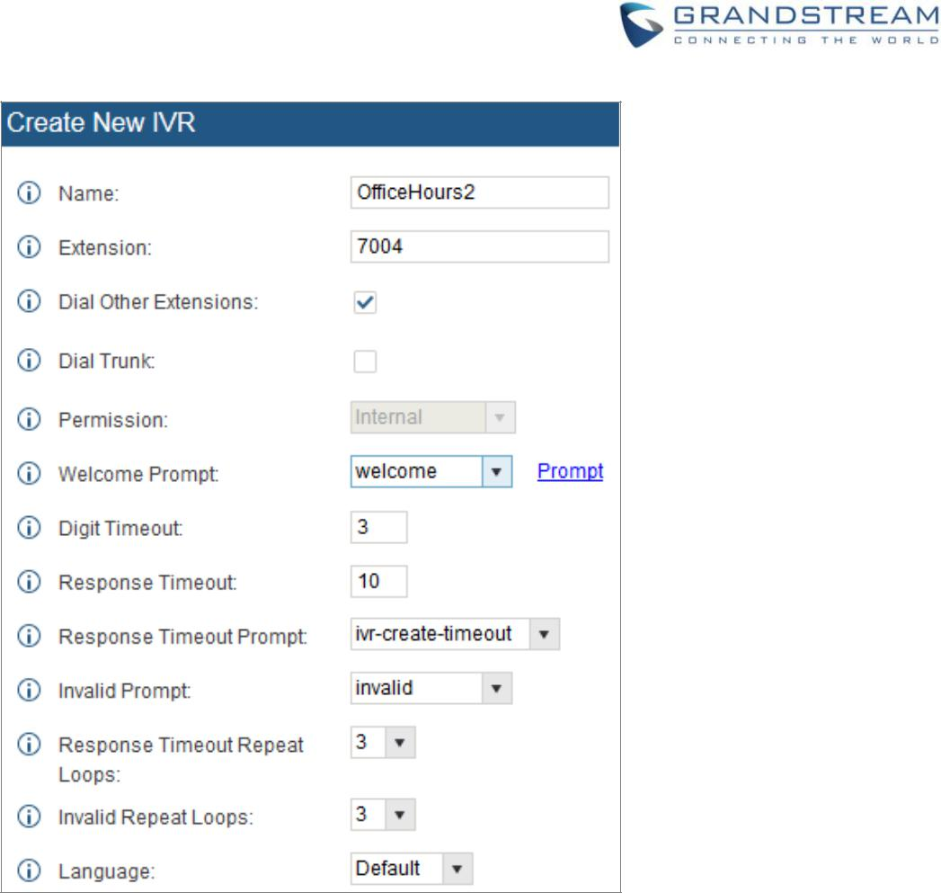

**Figure 21: IVR - Create New IVR**

1. The next section on configuring an IVR would be the Key Pressing Events. Users can direct calls based on a callers selection. For example, a caller reaches the IVR and the Welcome Prompt plays,

“Thank you for calling Grandstream Networks. For support, please dial 0. For Sales, please dial 1.” Click on the drop down box for the first event, which is “Press 0” and select Extension. Another drop down box will appear and the user can then select an extension from the list. For this example, the user selects Extension 1000.

1. For Key Pressing Event “Press 1” click on the drop down box and select Extension. User selects Extension 101. Besides from Extension as a Key Pressing Event, the user can select Voicemail, Conference Room, Voicemail Group, IVR, Ring Group and many more.

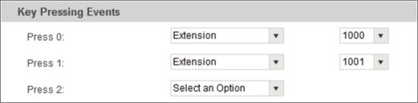

**Figure 22: IVR - Key Pressing Events**

8. Click “Save” at the bottom and then click on “Apply Changes” at the top.

UCM6510 Basic Configuration Guide Page 20 of 29



**TRUNKS**

**ANALOG TRUNKS**

Go to Web GUI->**PBX**->**Basic/Call Routes**->**Analog Trunks** to add and edit analog trunks.

* Click on "Create New Analog Trunk" to add a new analog trunk
* Click on  to edit the analog trunk
* Click on  to delete the analog trunk

The UCM6510 has built-in FXO ports which allows it to pull in PSTN lines and provide analog trunk service. For this example, we will configure an analog line that is connected to FXO1.

**SET UP ANALOG TRUNK**

1. Click on “Create New Analog Trunk”.
2. For “Channels” select 1.
3. Trunk Name is set to “Analog1”.
4. “Caller ID Scheme” is set for “Bellcore/Telcordia”. Depending on the provider, users can select other schemes.
5. “Tone Country” is set to “United States of America (USA)” since this tutorial is setup in the North American region. Users can click the dropdown box to select an option more suited for their region.
6. Click “Save” and then click on “Apply Changes” at the top.

UCM6510 Basic Configuration Guide Page 21 of 29

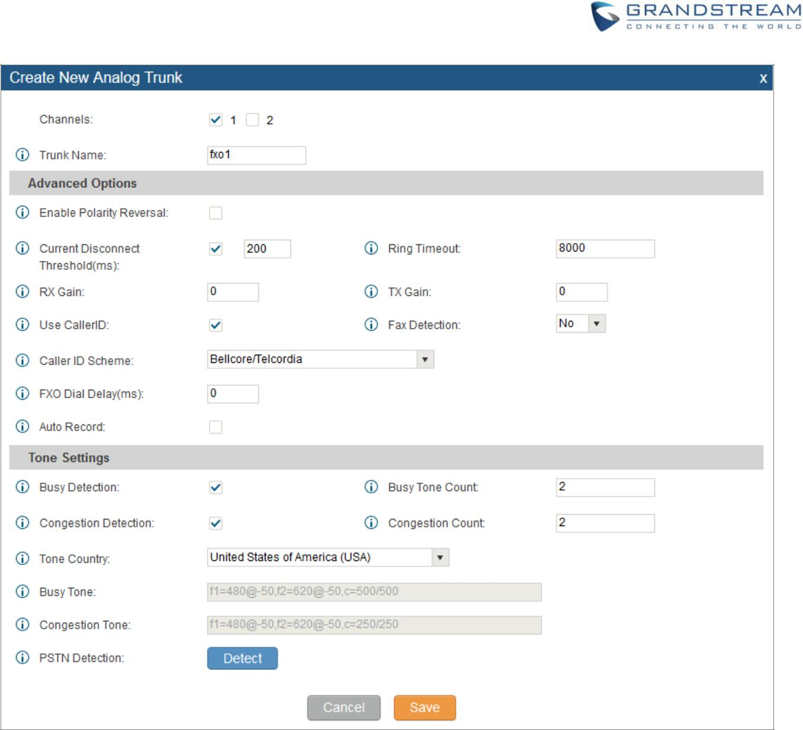

**Figure 23: Analog Trunks - Create New Analog Trunk**

**Note:** If there are reports of calls being dropped and lines are not disconnecting properly, this could meanthat there are line settings mismatched. The UCM6510 offers an auto detect feature that tests the line and provides the best possible settings. This option is called “PSTN Detection” which can be found under the

Analog trunk configuration page.

**VOIP TRUNKS**

VoIP trunks can be configured under Web GUI->**PBX**->**Basic/Call Routes**->**VoIP Trunks**. Once created, the VoIP trunks will be listed with Provider Name, Type, Hostname/IP, Username and Options to edit/detect the trunk.

* Click on "Create New SIP Trunk" to add a new VoIP SIP trunk
* Click on  to configure detailed parameters for the VoIP SIP trunk

UCM6510 Basic Configuration Guide Page 22 of 29



* Click on  to configure Direct Outward Dialing (DOD) for the SIP Trunk
* Click on  to start LDAP Sync
* Click on  to delete the VoIP trunk

There are 4 different types of VoIP trunks that can be configured:

* Peer SIP Trunk
* Register SIP Trunk
* Peer IAX Trunk
* Register IAX Trunk.

This tutorial will demonstrate how to configure a SIP Registered Trunk.

**SET UP VOIP TRUNK**

1. Click on “Create New SIP Trunk”.
2. Click the dropdown box for Type and select “Register SIP Trunk”.
3. Enter a name for “Provider Name” e.g., GSTrunk.
4. Configure the IP address or URL of the VoIP providers server as the “Host Name” e.g., sip.grandstream.com.
5. Input the username to authenticate with the VoIP provider as the “Username” e.g, 6266389172.
6. Enter password for username to authenticate with VoIP provider server.
7. Enter the AuthID. This is the SIP service subscriber’s ID used for authentication. If not configured, the CallerID will be used for authentication.
8. Enter an outbound proxy if the provider requires one.
9. Click “Save” and then “Apply Changes” at the top.

UCM6510 Basic Configuration Guide Page 23 of 29

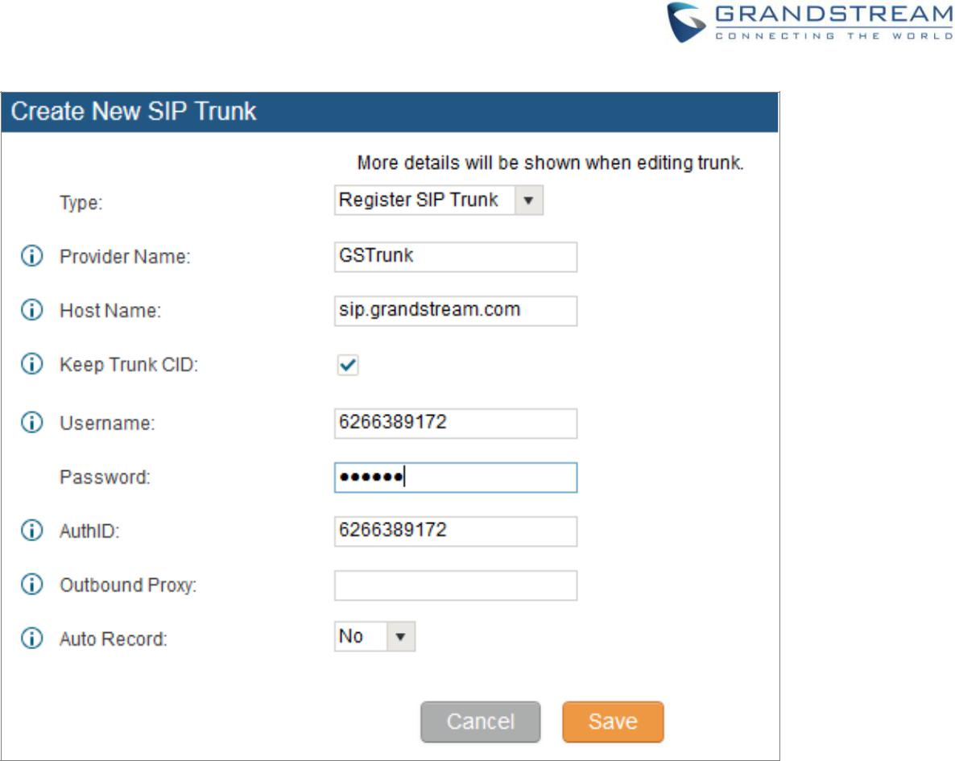

**Figure 24: VoIP Trunks - Create New Register SIP Trunk**

After creating the SIP trunk, users can click the  on the right of the VoIP trunk for more configuration

options.

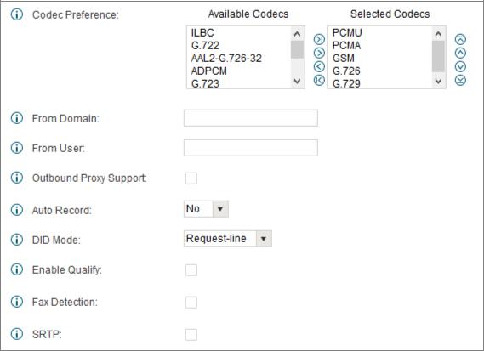

**Figure 25: VoIP Trunks - Edit VoIP Trunk**

UCM6510 Basic Configuration Guide Page 24 of 29



To verify if the SIP trunk is registered, the user may navigate to Web UI->**Status** to check the trunk status.

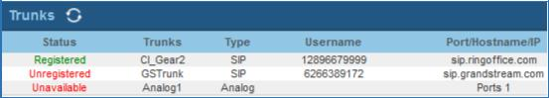

**Figure 26: Status - Trunks**

**DIGITAL TRUNKS**

Please refer to sample T1 trunk configuration in the document here: [http://www.grandstream.com/products/ucm_series/ucm65xx/documents/how_to_configure_t1_on_ucm65](http://www.grandstream.com/products/ucm_series/ucm65xx/documents/how_to_configure_t1_on_ucm6510.pdf) [10.pdf](http://www.grandstream.com/products/ucm_series/ucm65xx/documents/how_to_configure_t1_on_ucm6510.pdf)

UCM6510 Basic Configuration Guide Page 25 of 29



**CALL ROUTES**

**OUTBOUND ROUTES**

In the UCM6510, an outgoing calling rule pairs an extension pattern with a trunk used to dial the pattern. This allows different patterns to be dialed through different trunks (e.g., "Local" 7-digit dials through a FXO while "Long distance" 10-digit dials through a low-cost SIP trunk). Users can also set up a failover trunk to be used when the primary trunk fails.

Go to Web GUI->**PBX**->**Basic/Call Routes**->**Outbound Routes** to add and edit outbound rules.

* Click on "Create New Outbound Rule" to add a new outbound route
* Click on  to edit the outbound route
* Click on  to delete the outbound route
* On the UCM6510, the outbound route priority is based on “Best matching pattern”. For example, the

UCM6510 has outbound route A with pattern 1xxx and outbound route B with pattern 10xx configured. When dialing 1000 for outbound call, outbound route B will always be used first. This is because pattern 10xx is a better match than pattern 1xxx. Only when there are multiple outbound routes with the same pattern configured, users can click on  to move the outbound route up/down to

arrange the priority among those outbound routes.

**SET UP OUTBOUND ROUTE**

1. Click “Create New Outbound Rule”.
2. Configure the name of the Calling Rule. For example, ‘Local’, ‘LongDistance’ and etc.
3. Create a dial pattern.

For 7 digit dialing (Local) the pattern will look like this: XXXXXXX. This means that any 7 digits will use this route. For 10 digit dialing the pattern would look like this: NXXNXXXXXX. If a ‘1’ is required before dialing out, the dial patter can be configured in this manner: 1NXXNXXXXXX.

In this example, the dial pattern is going to be created for local 7 digit dialing so the pattern is

XXXXXXX.

UCM6510 Basic Configuration Guide Page 26 of 29



1. Next, set a “Privilege Level”. There are 4 Privilege Levels; Internal, Local, National, International. Internal is the lowest level of security whereas international is the highest level of security.

The way that Privilege Levels are used could be thought of as door locks. Extensions are granted with “Permissions” that can be seen as keys. If an Extension is configured with an Internal permission, it CANNOT access an outbound route with a Privilege level of Local, National and International. A user configured with National permission can access routes that have a Privilege Level of Internal, Local, National, but not International.

1. The pattern that was configured is a 7 digit dialing pattern. For “Use Trunk” select the Analog Trunk or select the desired trunk for this particular dial pattern. For long distance calls, it may be cost effective to route the calls to SIP trunk versus going through a local PSTN line.
2. Click “Save” and then click on “Apply Changes” at the top.

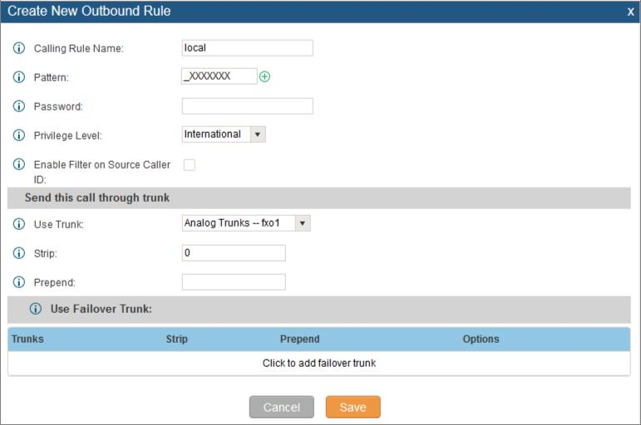

**Figure 27: Routes – Create Outbound Route**

UCM6510 Basic Configuration Guide Page 27 of 29



**INBOUND ROUTES**

In the UCM6510, an incoming calling rule allows for various inbound destinations. Users can route inbound calls by DID, to Extension, Voicemail, Conference Room, Queue, Ring Group, Page, Voicemail Group, FAX, DISA or IVR. These inbound routes can also be triggered based on a time condition as well.

Inbound routes can be configured via Web GUI->**PBX**->**Basic/Call Routes**->**Inbound Routes**.

* Click on "Create New Inbound Rule" to add a new inbound route
* Click on "DID Features" to configure DID features for the inbound route
* Click on "Blacklist" to configure blacklist for all inbound routes
* Click on  to edit the inbound route
* Click on  to delete the inbound route

This section of the tutorial will provide instructions on how to setup an inbound route for a Registered SIP Trunk. Inbound calls into this SIP trunk will have a default destination as well as a time conditioned destination.

**SET UP INBOUND ROUTE**

1. Click on “Create New Inbound Rule”.
2. For “Trunks” select the SIP trunk that has been configured. (e.g. GS Trunk).
3. The DID pattern can be composed of two parts, divided by a ‘/’ character. The first part is used to specify the dialed number and the second part is used to specify the caller ID, which is optional. If caller ID section is entered it means only the extension with the specific caller ID is allowed to call into this trunk.
4. “Privilege level” can be left as Internal.
5. Click the dropdown box for “Default Destination” and select IVR. Then select the IVR extension.
6. Next, click on “Click to add Time Condition”.
7. Enter a “Start Time” of 8am, “End Time” of 6pm.
8. Next select By Week for “Date” and select Monday-Friday.

UCM6510 Basic Configuration Guide Page 28 of 29



9. For “Destination” select Extension and choose an extension number.

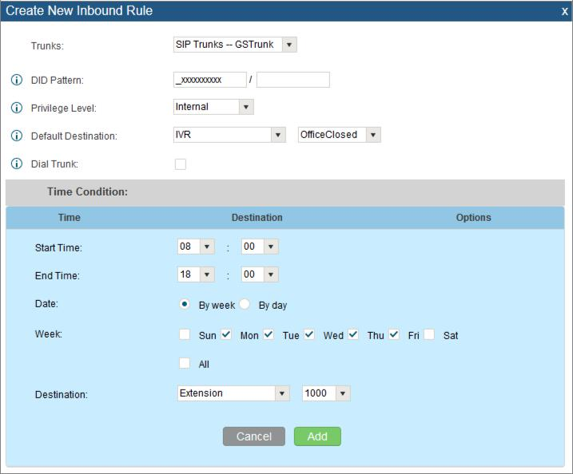

**Figure 28: Routes - Create Inbound Route**

When a call is received on this SIP trunk during the hours of 8am to 6pm from Monday to Friday it will be routed to extension 1000. All calls outside of this condition will be routed to the IVR “OfficeClosed”.

If there are any questions or concerns, please feel free to get in contact with Grandstream Networks support by calling (617) 566-9300 or create a support ticket by clicking this [link.](http://esupport.grandstream.com/support/customerportal/login.php)

* ***Asterisk is a Registered Trademark of Digium, Inc.***

UCM6510 Basic Configuration Guide Page 29 of 29