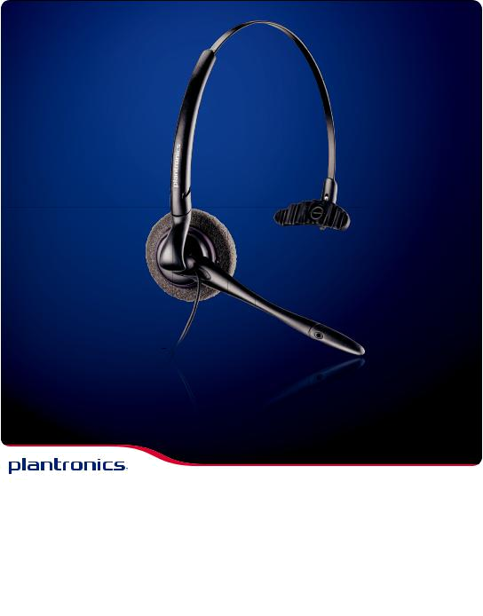
Remove loud tones with
SoundGuard® technology

Filter out background sounds with the noise-canceling microphone

DuoSet gives you options

DuoSet® Headset

For clear conversations in even noisy environments, the DuoSet offers audio clarity and wearing style choice of over-the-ear, over-the-head or behind-the-head with the optional neckband.
DuoSet®

Whether worn over-the-ear or over-the-head, the convertible style DuoSet allows you to make good use of your hands to multi-task. The headset is comfortably secure, and the sound quality is superb.

DUOSET KEY FEATURES

- Over-the-head stability or over-the-ear convenience for the busy office professional.

- Superior Sound. SoundGuard® technology provides natural voice tone and removes loud tones, as well as occasional noises and crackles on the line.

- Noise-canceling microphone filters out background sounds for heightened speech clarity.

- Quick Disconnect™ lets you walk away from your phone while still wearing your headset.

- Soft ear cushion for all day comfort.

- Adjustable headband allows wearing on either ear.

- Lightweight comfort.

- Warranty: Two years for unsurpassed durability.
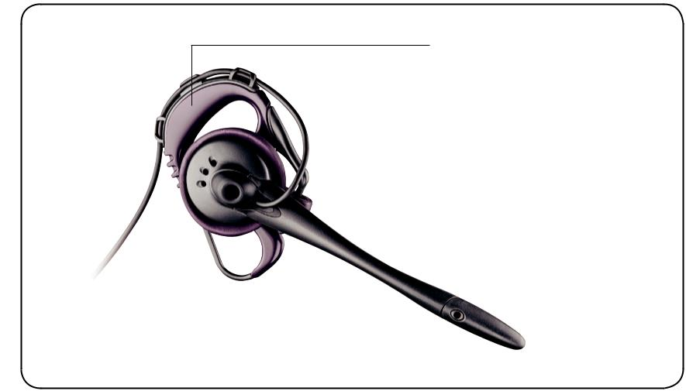

Easily converts
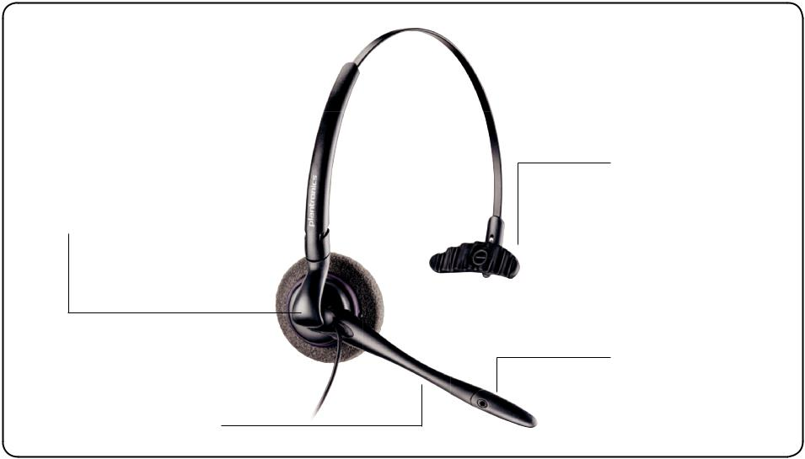

to over-the-ear

wearing style

Optimal boom length that stays out of the line of sight for the user

Ergonomic T-Pad

designed to not

catch hair

Noise-canceling microphone blocks out background noise

Flexible ear loop

fits any ear
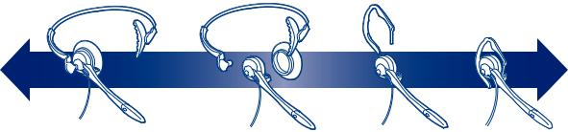

Headset quickly converts from over-the-head to over-the-ear wearing style.

DuoSet headsets require a Plantronics audio processor, USB audio processor, or direct connect cable to connect to phone, PC or computer.
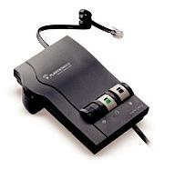

 | VISTA® M22 AUDIO PROCESSOR
 | The Vista M22 audio processor delivers precise levels of listening
 | comfort, sophisticated hearing protection, and superior audio
 | performance. The Vista M22 includes Clearline™ audio to improve
 | call quality in any environment, especially wideband VoIP.
 | DA45™ USB AUDIO PROCESSOR
 | Compatible with all Plantronics H-series headsets, this headset-
 | to-USB adapter/audio processor brings superior call clarity to PC-
 |  |  | based communications. The DA45 USB provides advanced audio
 | technologies, plug-and-play connectivity, and Quick Disconnect.
Operating Frequency: |  |  | Standard Band
Headset Microphone: |  |  | Noise-canceling or Voice Tube
Headset Weight: |  |  | 22 g Over-the-Ear
 |  |  | 36 g Over-the-Head
Compatibility: |  |  | Plantronics Audio Processor
Wearing Styles: |  |  | Over-the-Ear, Over-the-Head
Limited Warranty: |  |  | 2 years
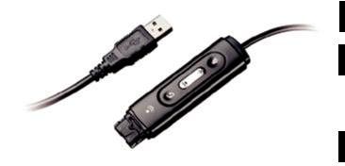

For more information about the DuoSet or other Plantronics products, please visit our website at plantronics.com

©2012 Plantronics, Inc. All rights reserved. Plantronics, the logo design, the Sound World graphic, Clearline, DA45, DuoSet, Quick Disconnect, SoundGuard, and Vista are trademarks or registered trademarks of Plantronics, Inc. 06/12


